Dynamics of Wetting of Ultra-hydrophobic Surfaces

Alireza Mohammad Karim, Pirouz Kavehpour
Department of Mechanical and Aerospace Engineering, University of California, Los Angeles, Los Angeles,
CA 90095, USA

Presented at the 17th International Coating Science and Technology Symposium
September 7-10, 2014
San Diego, CA, USA

ISCST shall not be responsible for statements or opinions contained in papers or printed in its publications.

Abstract:
Experimental investigations by applying forced spreading through Wilhelmy plate method have been done with tensiometer for several different liquid mixtures with almost same surface tensions but different dynamic viscosities on solid surfaces with large water repellency in the ultra hydrophobic region to see the effect of the dynamic viscosity of fluid on the characteristics dynamics of wetting on ultra-hydrophobic surfaces. Then the results obtained from tensiometer measurements have been compared with the results obtained from Rothstein et. al. experiments applying optical method for their dynamic contact angle measurements. We have been able to show that in the ultra hydrophobic region, the hydrodynamic theory cannot be applied for describing the dynamics of wetting for complete range of Capillary number. For low contact line velocity, the hydrodynamic theory is valid for describing the dynamics of wetting on hydrophobic surfaces. Beyond the critical contact line velocity, the viscous stress effect decreases abruptly hence the hydrodynamic theory cannot be applied for describing wetting dynamics on ultra-hydrophobic surfaces. As dynamic viscosity of the fluid increases the hydrodynamic theory is valid for larger range of capillary number. The dynamics of wetting for receding and advancing motions are not the same. The advancing dynamic contact angle is almost independent on contact line velocity and is almost constant for whole range of contact line velocity. We could finally show that our results from experimental measurement techniques through applying tensiometer (e.g. Measuring the dynamic contact angles by applying the force balance method) have good consistency with the results obtained for dynamic contact angles using optical method.

Introduction:
Controlling the surface wettability of hydrophobic and super hydrophobic surfaces has extensive industrial applications ranging from coating, painting and printing technology and waterproof clothing to efficiency increase in power and water plants. Some of the examples of applications of the ultra-hydrophobic surfaces in the nature are the wings of insects and the leaves of the plants. Wings of insects and leaves of plants need to be protected from the water hence they have ultra-hydrophobic surfaces⁵. Other examples of the ultra-hydrophobic surfaces in industry and technology are efficient condensers, efficient power plants, house paint, bathroom mirrors with non-fogging characteristic, and intricate fluidic devices⁵. Self-cleaning characteristic of the ultra-hydrophobic surfaces is a very crucial effect of ultra-hydrophobic surfaces due to its effect to remove dusts and debris out of the surfaces without wetting the surfaces by the ability of rolling off from the ultra-hydrophobic surface and hence diminishing the requirement of usage of any active cleaning to do this job⁶. One of other most important applications of ultra-hydrophobic surfaces are in the satellite communications technology which can effect on increasing the efficiency of the signal communications of their systems in any conditions of weather (e.g. during heavy snow or heavy rain condition) to make the signal communications more accurate and reliable. This requires enhancing the knowledge about the dynamics of wetting on such surfaces by completing the knowledge on the dynamics of wetting on surfaces with high water repellency, which are in ultra hydrophobic region. Dynamics of wetting for hydrophilic and hydrophobic surfaces have been investigated for a long period of time and has been verified that they follow the universal Hoffmann-Voinov-Tanner (HVT) law^{1,2,3} or another version of the dynamics of wetting proposed by deGennes⁴, in which both derived by applying hydrodynamics theory, or the molecular-kinetic theory proposed by Blake and Haynes^{7,8}, or combined hydrodynamic-molecular-kinetic theory proposed by Petrov⁹. But there has not been any research on modeling the dynamics of wetting of ultra-hydrophobic surfaces despite to their extensive applications in several areas in the daily life, technology and science, etc. Hence due to the huge range of applications of ultra-hydrophobic surfaces, we have done experimental investigations on their wetting dynamics, which can give us more knowledge about their dynamics of wetting characteristics.

Experimental Methods:
Optical method and Tensiometer have been applied to measure the dynamic contact angles.

Tensiometer Measurements (Wilhelmy Plate Method):
Force method using the Tensiometer has been applied to do the experiments. Tensiometer measures the advancing dynamic contact angle and receding dynamic contact angle by moving the sample platform, which is holding the pool of liquid, upward and downward, respectively. The force sensor measures the forces applied on the plate of solid substrate and then it calculates the advancing dynamic contact angle and receding dynamic contact angle using the theoretical formula relating the measured force applied on the plate to the advancing and receding dynamic contact angles. The speed of the motion of the sample platform can be set to a constant specific speed to have a steady motion of the sample platform during measurement.

Optical Method:
This method has been done with Rothstein group¹⁰. The dynamic contact angles of both advancing and receding have been measured by capturing the menisci of the fluid on the solid surface during the immersion and emersion of the Wilhelmy plate into/out of the pool of the fluid.

Materials:
We have done the experiments on three different mixtures of Poly Ethylene Glycol (PEG) mixed with Pure Water in different weight ratios, with almost same surface tension but with different dynamic viscosity of liquid mixtures, to see the effect of the dynamic viscosity of the liquid mixtures on the dynamics of wetting of ultra-hydrophobic surfaces. The PEG is a water-soluble polymer that was used in different weight ratios to be mixed with pure DI water to make different mixtures for making variations in physical property of the mixture especially for the dynamic viscosity. The dynamic viscosities of all three PEG/water mixtures have been measured using Rheometer. All three PEG/water mixtures behaved Newtonian (e.g. the dynamic viscosity of each PEG/water mixture was constant and independent of shear rate of strain). The densities of all PEG/water mixtures have been measured using the tensiometer.
The surface tension of all PEG/water mixtures have been also measured using the tensiometer applying ring-tear off method and also the Wilhelmy plate method. The solid substrates that have been used to do the experimental investigation of wetting dynamics were ultra-hydrophobic sprayed glasses (e.g. glasses have been sprayed uniformly on their both sides using WX2100 paint).

Results and Discussion:
The advancing dynamic contact angle has been found to be almost independent of the capillary number at it is almost constant value for the whole range of contact line velocity. The receding dynamic contact angle versus capillary number follows Hoffmann-Voinov-Tanner law for small capillary number range which corresponds to small contact line velocity range and the receding dynamic contact angle relation to capillary number deviates from Hoffmann-Voinov-Tanner law beyond that region and that the dependency of receding dynamic contact angle to the capillary number decreases tremendously. This is due to the fact that for low contact line velocity, the effect of viscous stress is significant and hence the hydrodynamic theory can be applied but after some certain value of contact line velocity the effect of viscous stress is decreased abruptly that the hydrodynamic theory is not an appropriate model to be used to describe the dynamics of wetting of fluid on super hydrophobic surfaces. As it is shown in the figure the receding dynamic contact versus capillary number follows the HVT law up to the critical value of the capillary number corresponding to the critical contact line velocity beyond which the dependency of the receding dynamic contact angle to the capillary number decreases abruptly.
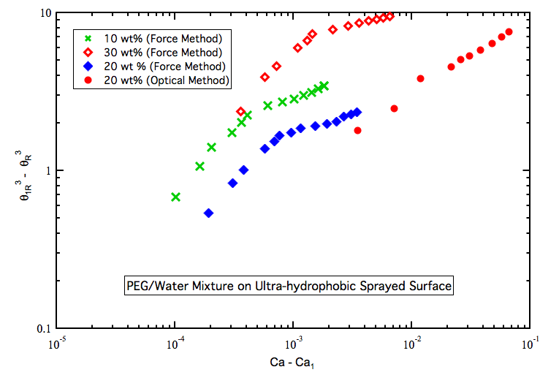
Figure 1. Receding dynamic contact angle versus capillary number for 2 different PEG/Water ratios on Ultra-hydrophobic sprayed glass.

For ultra-hydrophobic surfaces, the dynamic contact angle variation versus contact line velocity for advancing motion is not the same as the dynamic contact angle variation versus contact line velocity in receding motion. The results obtained from optical method have been shown that have a great consistency with tensiometer results as it is shown in the figure. As the dynamic viscosity of the fluid increases the critical capillary number is increasing meaning the hydrodynamic theory can be applied for larger range.

Bibliography:
- Hoffman, R. L., (1975), J. Coll. Inter. Sci., Vol. 50, 228.
- Cox, R. G., (1986), “The dynamics of the spreading of liquids on a solid surface. Part 1. Viscous flow”, J. Fluid Mech., Vol. 168, 169-194.
- Voinov, O. V., (1976), “HYDRODYANMICS OF WETTING”, Fluid. Dyn., Vol. 11, 714-721.
- de Gennes, P. G., (1986), “Deposition of Langmuir-Blodgett layers”, Coll. Polym. Sci., Vol. 264, 463-465.

- Gao, L., and McCarthy, T. J. (2009), “Wetting and Superhydrophobicity”, Langmuir, Vol. 25, No. 24, 14100-14104.
- Barthlott, W. and Neinhuis, C., Planta, 1997, 202.
- Blake, T. D., and Haynes, J. M., [1969], “Kinetics of liquid/liquid displacement” J. Colloid Interface Sci., 30, 421-423.
- Blake, T. D. and Berg, J. C., [1993], “Wettability: kinetics of Liquid/Liquid Displacement’, Marcel Dekker, New York, p. 251-309.
- Petrov, P. G. and Petrov, J. G., [1992], “A Combined Molecular-Hydrodynamic Approach to Wetting Kinetics”, Langmuir, 8, 1762-1767.
- Kim, J and Rothstein, J, [2013], “Dynamic Contact Angles of Newtonian and Viscoelastic Fluids on Hydrophobic and Superhydrophobic Surfaces”, 85th Annual Meeting of the Society of Rheology, Montreal, Canada.

