Experimental Demonstration of Shape Control with Marangoni-Driven Patterning

Steven Stanley^{1,2}, Saurabh Usgaonkar³, Christopher Ellison³, and Roger T. Bonnecaze^{1,2}

¹McKetta Department of Chemical Engineering, The University of Texas at Austin, 200 E. Dean Keeton Stop C0400, Austin, Texas, 78712, United States

²Nanomanufacturing Systems for Mobile Computing and Mobile Energy Technologies (NASCENT) Center, The University of Texas at Austin, Austin, Texas, 78712, United States

³Department of Chemical Engineering and Materials Science, The University of Minnesota, Minneapolis, Minnesota 55455, United States

Presented at the 20th International Coating Science and Technology Symposium
September 20-23, 2020
Minneapolis, MN, USA

ISCST shall not be responsible for statements or opinions contained in papers or printed in its publications.

Extended Abstract
Applying topography to polymer thin films has several applications in the electronics, optics, adhesive, and antifouling industries. Several methods and techniques exist for patterning thin films, including optical lithography and imprint lithography. One alternative patterning method that has been explored in recent years is Marangoni-driven patterning (MDP), which harnesses photo-imposed surface tension gradients to generate topography in thin polymer films [1–9]. This relatively new patterning technique has potential applications in functional coatings for improving light capture [10], adhesion [11] and antibiofouling properties [12]. Patterns could also be used as an etch barrier for electronics fabrication. On account of its processing advantages, MDP is particularly promising for patterning at the roll-to-roll scale and could be applied in generating flexible functional coatings, electronics and metamaterials. Considering the size scales previously demonstrated by MDP, one particularly promising application is in patterning flexible terahertz spectrum metamaterials [13–15].

MDP begins by selectively exposing a photosensitive polymer film of initial thickness, h₀, to UV light using a photomask. Contact photomasks have been used historically for the exposure step, but other maskless exposure techniques could also be used [16]. In the UV exposed regions of the film, a chemical reaction occurs and increases the surface tension. This surface energy profile is dormant and activates upon heating the polymer above its glass transition temperature, which allows the polymer to flow into the regions of higher surface tension. Initially, where the surface tension gradient is sharp, double peaks form but eventually merge into a more sinusoidal topography with central height, h_{c}. If the polymer is annealed for long enough, diffusion of the surface tension promoter weakens Marangoni forces, allowing capillary forces to replanarize the film. If the polymer is cooled below its glass transition temperature, the topography can be preserved. This topography can then be used as a functional coating or could be used as an etch barrier for pattern transfer.
Controlling Feature Shape-Theory
Controlling the feature shape and critical dimensions is essential in patterning applications, and it has been shown that MDP suffers from poor shape control [8]. Simulations show that two-dimensional patterns generated using an intuitive square-shaped photomask results in rounded corners, curved sidewalls, and contours that are too small or too large, as shown in Fig. 1. This poor pattern overlap results from a combination of detrimental capillary and diffusion forces. Capillary forces drive the surface to assume a minimal energy conformation, thereby rounding the square. Additionally, diffusion causes the initially square surface tension profile to blur into a more circular shape. To compensate for these forces, it is possible to manipulate the exposure and initial surface tension field to generate more favorable flow patterns and better feature-target overlap. In recent simulation-based work, we demonstrated an algorithm for optimizing the film exposure and resulting surface tension gradient for improved pattern formation [8]. This work showed that by judiciously placing exposure “pixels” in the photomask, the fluid flow could be altered to form sharper features more in line with the target contour. Building on that work, here we experimentally determine the effectiveness of the photomask optimization method.

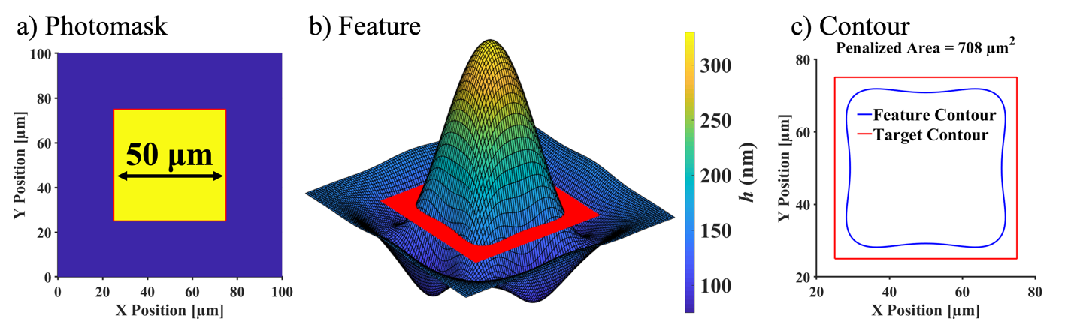

Figure 1. Photomask, simulated features, and pattern contours compared to 50x50 μm² target. Yellow regions of the photomask are exposed with higher surface tension, whereas dark areas are opaque. The polymer flows towards the center of the exposed, higher surface tension region. Feature profile and contours were taken at an annealing time of 5,000 seconds. The red outline in a) shows the target dimensions. Feature contours are extracted at h = h₀ = 150 nm, denoted by the red cut in b). This red cut is for demonstration only and do not represent the dimensions of the target. Note that the features are not drawn to scale, where the lateral scale is on the order of microns, while the vertical scale is on the order of nanometers. Details regarding the simulation will be provided later.
Fig. 2 shows the optimized photomasks for the square and L-shaped features using the primary parameters at the short annealing time. Note that the square photomask is generally larger than the target so as to correct the previous undershoot. Furthermore, the corners have been elongated and the edges bowed outwards to compensate for the corner and edge rounding. The L-shape mask, on the other hand, is larger in some areas and carved out in others. These pixel-level corrections had a generally positive effect on the outer regions of the resulting L-shape contour, but the concave, interior corner did not receive the same degree of correction. This highlights the limitation of the method in simultaneously optimizing different pattern structures. From simulations, the quality of the resulting patterns was satisfactory and comparable to our previous study. We next examine the effectiveness of the method in practice.

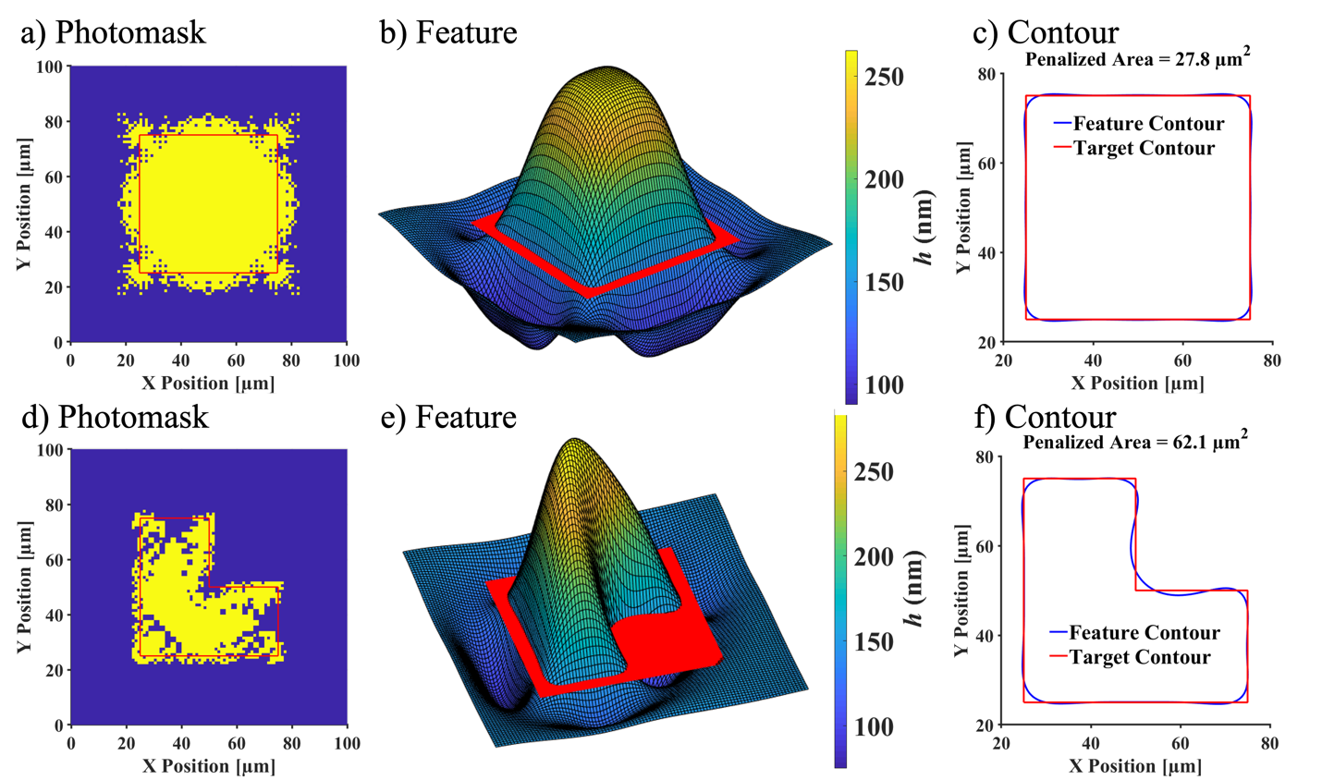

Figure 2. Optimized square and L-shaped photomasks, simulated features, and pattern contours compared to the corresponding targets. Feature profile and contours taken at an annealing time of 5,000 seconds. The optimized photomasks were obtained through the optimization method using the Sample 8 primary parameters. The red outline in a) and d) shows the target dimensions. The red cut in b) and e) is for demonstration only and does not represent the target dimensions. Feature contours are extracted at h = h₀ = 150 nm. Note that the features in b) and e) are not drawn to scale, where the lateral scale is on the order of microns, while the vertical scale is on the order of nanometers.
Controlling Feature Shape-Experiments
Experiments were performed on different size square masks and masks optimized for the square shape. The results are shown in Fig 3. Images were taken with an optical profilometer. The large square resulted in a structure closer to that of the target and the optimized mask did even better. This is borne out by quantitative measures of the error. Figure 4 shows the results of experiments with the L-shaped pattern. The optimized L-shaped pattern does a much better at reproducing the structure than the basic L-shaped photomask.

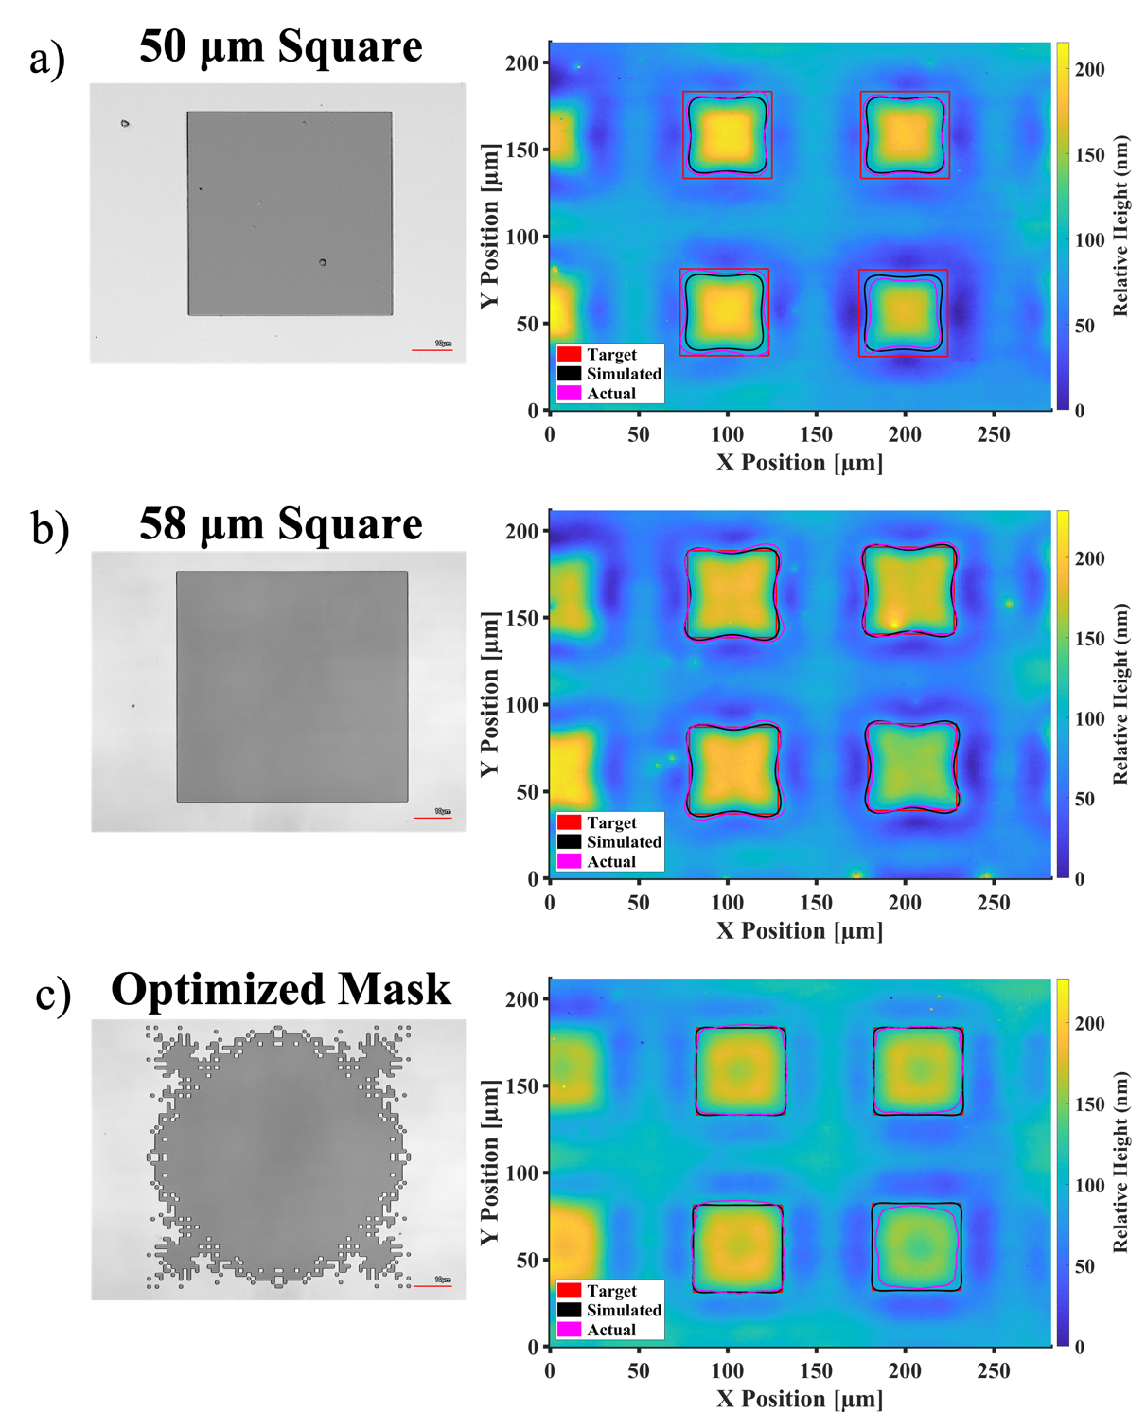

Figure 3. Square and optimized mask for square patterns (left) and the measured results (right) from optical profilometry. Feature profile and contours taken at an annealing time of 5,000 seconds. Simulated, actual and target feature profiles at the nominal average film thickness are shown by the colored lines noted in the legend. a) 50 μm square photomask, b) 58 μm square photomask and c) optimized photomask.

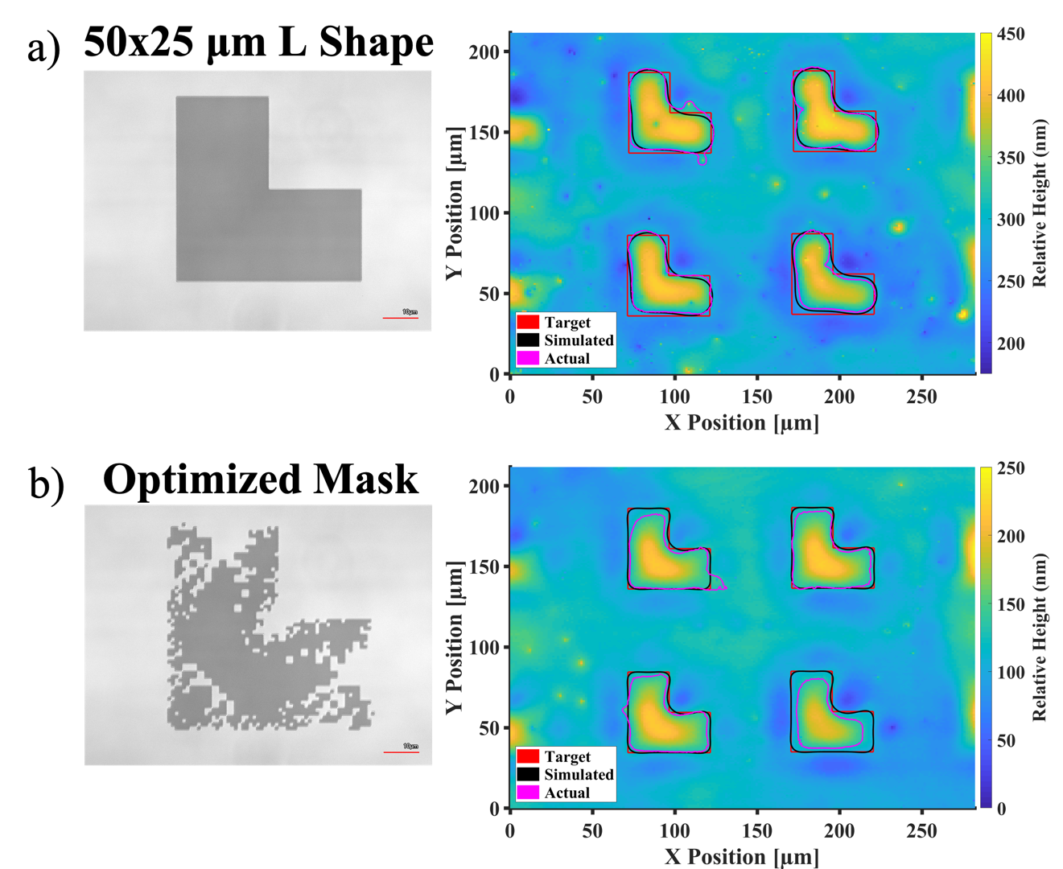

Figure 4. L-shape and optimized mask for L-shaped patterns (left) and the measured results (right) from optical profilometry. Feature profile and contours taken at an annealing time of 5,000 seconds. Simulated, actual and target feature profiles at the nominal average film thickness are shown by the colored lines noted in the legend. a) 50 μm x 25 μm L-shaped photomask and b) optimized photomask.
Conclusions
Shape control of three-dimensional features on a polymer film is possible with Marangoni-driven patterning by optimizing the photomask that creates the surface tension distribution on the film. The optimized photomask does substantially better than intuitive masks of the same dimensions. This demonstrates a new contactless, roll-to-roll process for potentially manipulating the surfaces of polymer films.

References
[1] J.M. Katzenstein, D.W. Janes, J.D. Cushen, N.B. Hira, D.L. McGuffin, N.A. Prisco, C.J. Ellison, Patterning by photochemically directing the Marangoni Effect, ACS Macro Lett. 1 (2012) 1150–1154. https://doi.org/10.1021/mz300400p.
[2] D.W. Janes, J.M. Katzenstein, K. Shanmuganathan, C.J. Ellison, Directing convection to pattern thin polymer films, J. Polym. Sci. Part B Polym. Phys. 51 (2013) 535–545. https://doi.org/10.1002/polb.23262.
[3] C. Bin Kim, D.W. Janes, D.L. McGuffin, C.J. Ellison, Surface energy gradient driven convection for generating nanoscale and microscale patterned polymer films using photosensitizers, J. Polym. Sci. Part B Polym. Phys. 52 (2014) 1195–1202. https://doi.org/10.1002/polb.23546.
[4] J.M. Katzenstein, C. Bin Kim, N.A. Prisco, R. Katsumata, Z. Li, D.W. Janes, G. Blachut, C.J. Ellison, A photochemical approach to directing flow and stabilizing topography in polymer films, Macromolecules. 47 (2014) 6804–6812. https://doi.org/10.1021/ma5010698.
[5] C. Bin Kim, D.W. Janes, S.X. Zhou, A.R. Dulaney, C.J. Ellison, Bidirectional Control of Flow in Thin Polymer Films by Photochemically Manipulating Surface Tension, Chem. Mater. 27 (2015) 4538–4545. https://doi.org/10.1021/acs.chemmater.5b01744.
[6] A.R. Jones, C. Bin Kim, S.X. Zhou, H. Ha, R. Katsumata, G. Blachut, R.T. Bonnecaze, C.J. Ellison, Generating Large Thermally Stable Marangoni-Driven Topography in Polymer Films by Stabilizing the Surface Energy Gradient, Macromolecules. 50 (2017) 4588–4596. https://doi.org/10.1021/acs.macromol.7b00055.
[7] T.A. Arshad, C. Bin Kim, N.A. Prisco, J.M. Katzenstein, D.W. Janes, R.T. Bonnecaze, C.J. Ellison, Precision Marangoni-driven patterning, Soft Matter. 10 (2014) 8043–8050. https://doi.org/10.1039/c4sm01284d.
[8] S.K. Stanley, C.J. Ellison, R.T. Bonnecaze, Control of Marangoni-driven patterning by an optimized distribution of surface energy Control of Marangoni-driven patterning by an optimized distribution of surface energy, J. Appl. Phys. 127 (2020) 065304. https://doi.org/10.1063/1.5132360.
[9] S.K. Stanley, R.T. Bonnecaze, Fundamental limits of Marangoni-driven patterning, Colloids Surfaces A Physicochem. Eng. Asp. 603 (2020) 125217. https://doi.org/10.1016/j.colsurfa.2020.125217.
[10] J.B. Kim, P. Kim, N.C. Ṕgard, S.J. Oh, C.R. Kagan, J.W. Fleischer, H.A. Stone, Y.L. Loo, Wrinkles and deep folds as photonic structures in photovoltaics, Nat. Photonics. 6 (2012) 327–332. https://doi.org/10.1038/nphoton.2012.70.
[11] C.S. Davis, D. Martina, C. Creton, A. Lindner, A.J. Crosby, Enhanced adhesion of elastic materials to small-scale wrinkles, Langmuir. 28 (2012) 14899–14908. https://doi.org/10.1021/la302314z.
[12] J.F. Schumacher, M.L. Carman, T.G. Estes, A.W. Feinberg, L.H. Wilson, M.E. Callow, J.A. Callow, J.A. Finlay, A.B. Brennan, Engineered antifouling microtopographies - Effect of feature size, geometry, and roughness on settlement of zoospores of the green alga Ulva, Biofouling. 23 (2007) 55–62. https://doi.org/10.1080/08927010601136957.
[13] I.E. Khodasevych, C.M. Shah, S. Sriram, M. Bhaskaran, W. Withayachumnankul, B.S.Y.Y. Ung, H. Lin, W.S.T.T. Rowe, D. Abbott, A. Mitchell, Elastomeric silicone substrates for terahertz fishnet metamaterials, Appl. Phys. Lett. 100 (2012) 61101. https://doi.org/10.1063/1.3665180.
[14] H. Tao, N.I. Landy, K. Fan, A.C. Strikwerda, W.J. Padilla, R.D. Averitt, X. Zhang, Flexible terahertz metamaterials: towards a terahertz metamaterial invisible cloak, in: 2008 IEEE Int. Electron Devices Meet., IEEE, 2008. https://doi.org/10.1109/iedm.2008.4796673.
[15] K. Fan, X. Zhao, J. Zhang, K. Geng, G.R. Keiser, H.R. Seren, G.D. Metcalfe, M. Wraback, X. Zhang, R.D. Averitt, Optically Tunable Terahertz Metamaterials on Highly Flexible Substrates, IEEE Trans. Terahertz Sci. Technol. 3 (2013) 702–708. https://doi.org/10.1109/tthz.2013.2285619.
[16] R. Menon, A. Patel, D. Gil, H.I. Smith, Maskless lithography, Mater. Today. 8 (2005) 26–33. https://doi.org/10.1016/s1369-7021(05)00699-1.

