**Flexible Transparent Conductive Film by Solution-based Coating and Light Sintering Method**

**I-Feng Wu1, Ying-Chih Liao1\***

**1 Department of Chemical Engineering, National Taiwan University, Taipei, Taiwan**

**\*Email address for correspondence:** [**liaoy@ntu.edu.tw**](mailto:liaoy@ntu.edu.tw)

Presented at the 20th International Coating Science and Technology Symposium

September 20-23, 2020

Minneapolis, MN, USA

ISCST shall not be responsible for statements or opinions contained in papers or printed in its publications.

**Extended Abstract (ten pages maximum):**

**Introduction**

Recently, transparent conductive films (TCFs) have been widely used in electronics, such as liquid crystal display, touch screen and solar cell. Indium tin oxide (ITO), as the most frequently-used transparent conductive oxide, is commonly utilized in the fabrication process of transparent conductive films. To prepare ITO thin films, traditional CVD or sputtering processes are regularly employed. However, these methods usually require high facility cost and restrictions. Consequently, solution-based coating process becomes an excellent candidate for ITO transparent conductive film manufacturing because it allows TCFs be fabricated by nanoparticle inks on flexible polymer substrates. Nevertheless, ink quality and drying behavior during coating process greatly influence roughness and packing density of films. The loose compact of nanoparticles deposited on substrate decreases electrical conductivity. Intense pulsed light (IPL), one of light sintering process, can effectively sinter large area transparent conductive oxides in short time period (~milliseconds). Also, during IPL sintering process, the substrate remains at nearly room temperature and the process is harmless to polymer substrate during the sintering process.

In this study, an ITO ink is formulated for coated transparent conductive films on flexible substrates with high transparency and conductivity. Dynamic light scattering is used to evaluate particle size of suspension. Blade coating is used to form transparent conductive film on flexible PET substrate. Effects of different IPL sintering parameters are tested to reach lower sheet resistance and higher figure of merit (FOM) value. The morphology will also be examined to investigate necking phenomena between particles in the sintering process. Moreover, UV-visible spectroscopy is used to evaluate transparency of transparent conductive film. The highly conductive transparent film can be produced through coating and sintering under room temperature. This research paves a new way for transparent conductive oxides sintering and TCFs fabrication as further application.

**Result and discussion**

First, because of the strong attractive force between nanoparticles, aggregation of ITO nanoparticles would strongly influence the quality of nanoparticle ink. Therefore, suitable dispersant and dispersing process were applied to formulate stably dispersed ITO nanoparticle ink. 2-[2-(2-Methoxyethoxy)ethoxy]acetic acid (TODS) was commonly used dispersant for metal oxides because C-O bonds in TODS structure could reinforce with ITO nanoparticle surface to form steric repulsion between particles. Ball milling was a mostly applied way for ink dispersion process because the shear force emerging from collisions could not only separate large aggregates but increase the adsorption of dispersants. Combined with ball milling process for 4 hr, the particle size of ITO ink can be reduced to ~145 nm as shown in Fig 1., which could be further applied on coating process. The main absorption peak of ITO ink was 306 nm, including in the light emission range of IPL (Fig 2). After absorbing light energy, light heat conversion effect could increase the surface temperature and further sinter ITO nanoparticles. For fabricating ITO films on substrate, 10wt% percent (based on ITO powder) of binder was added to improve the adhesion of nanoparticles on PET substrate during blade coating process. The coating process was undergone with 30 μm gap width blade and the coating speed was 40 mm/s.



Figure 1. Particle size of suspension under different ball milling time

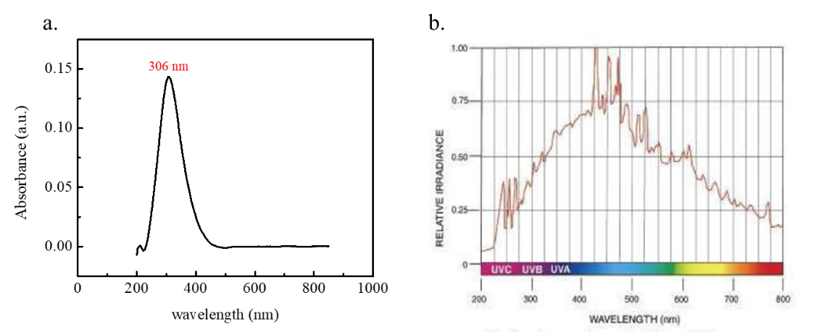

Figure 2. (a) UV-vis spectrum of ITO ink. (b) light emission range and intensity of IPL.

For IPL sintering, pulse energy, pulse number and emission time interval were important parameters. When pulse energy was too large or emission interval was too short, the ITO films could not tolerate high temperature and would be charred. However, if pulse energy was not enough or emission interval was too long, the ITO films could not increase temperature for sintering process. In our experiment, the best parameter for sintering was 1000 J divided into four small peaks (250 J each) repeated for four times pulses with 3000 ms time interval as shown in Fig 3. The sheet resistance of ITO film could reach 500 Ω/□ after IPL treatment.

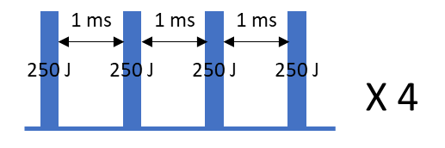

Figure 3. Scheme of IPL sintering parameter.

SEM images were also shown in Fig 4., we could observe that the necking grew between ITO nanoparticles and enhance the packing of nanoparticles to further increase ITO film conductivity. The image of ITO film was shown in Fig 5., the film was transparent enough to show the word behind. Transparency of as-prepared film was evaluated by UV-Vis spectrum as shown in Fig 6. After coated with ITO, light transmission of the ITO-PET film only showed slight decrease, but still larger than 90%, indicating good transparency of ITO-PET.

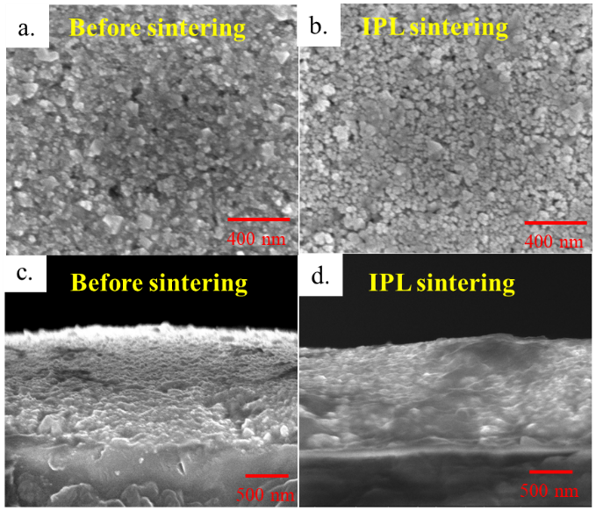

Figure 4. Top-view SEM images of ITO film (a) before (b) after IPL treatment and side-view SEM images of TO film (a) before (b) after IPL treatment.

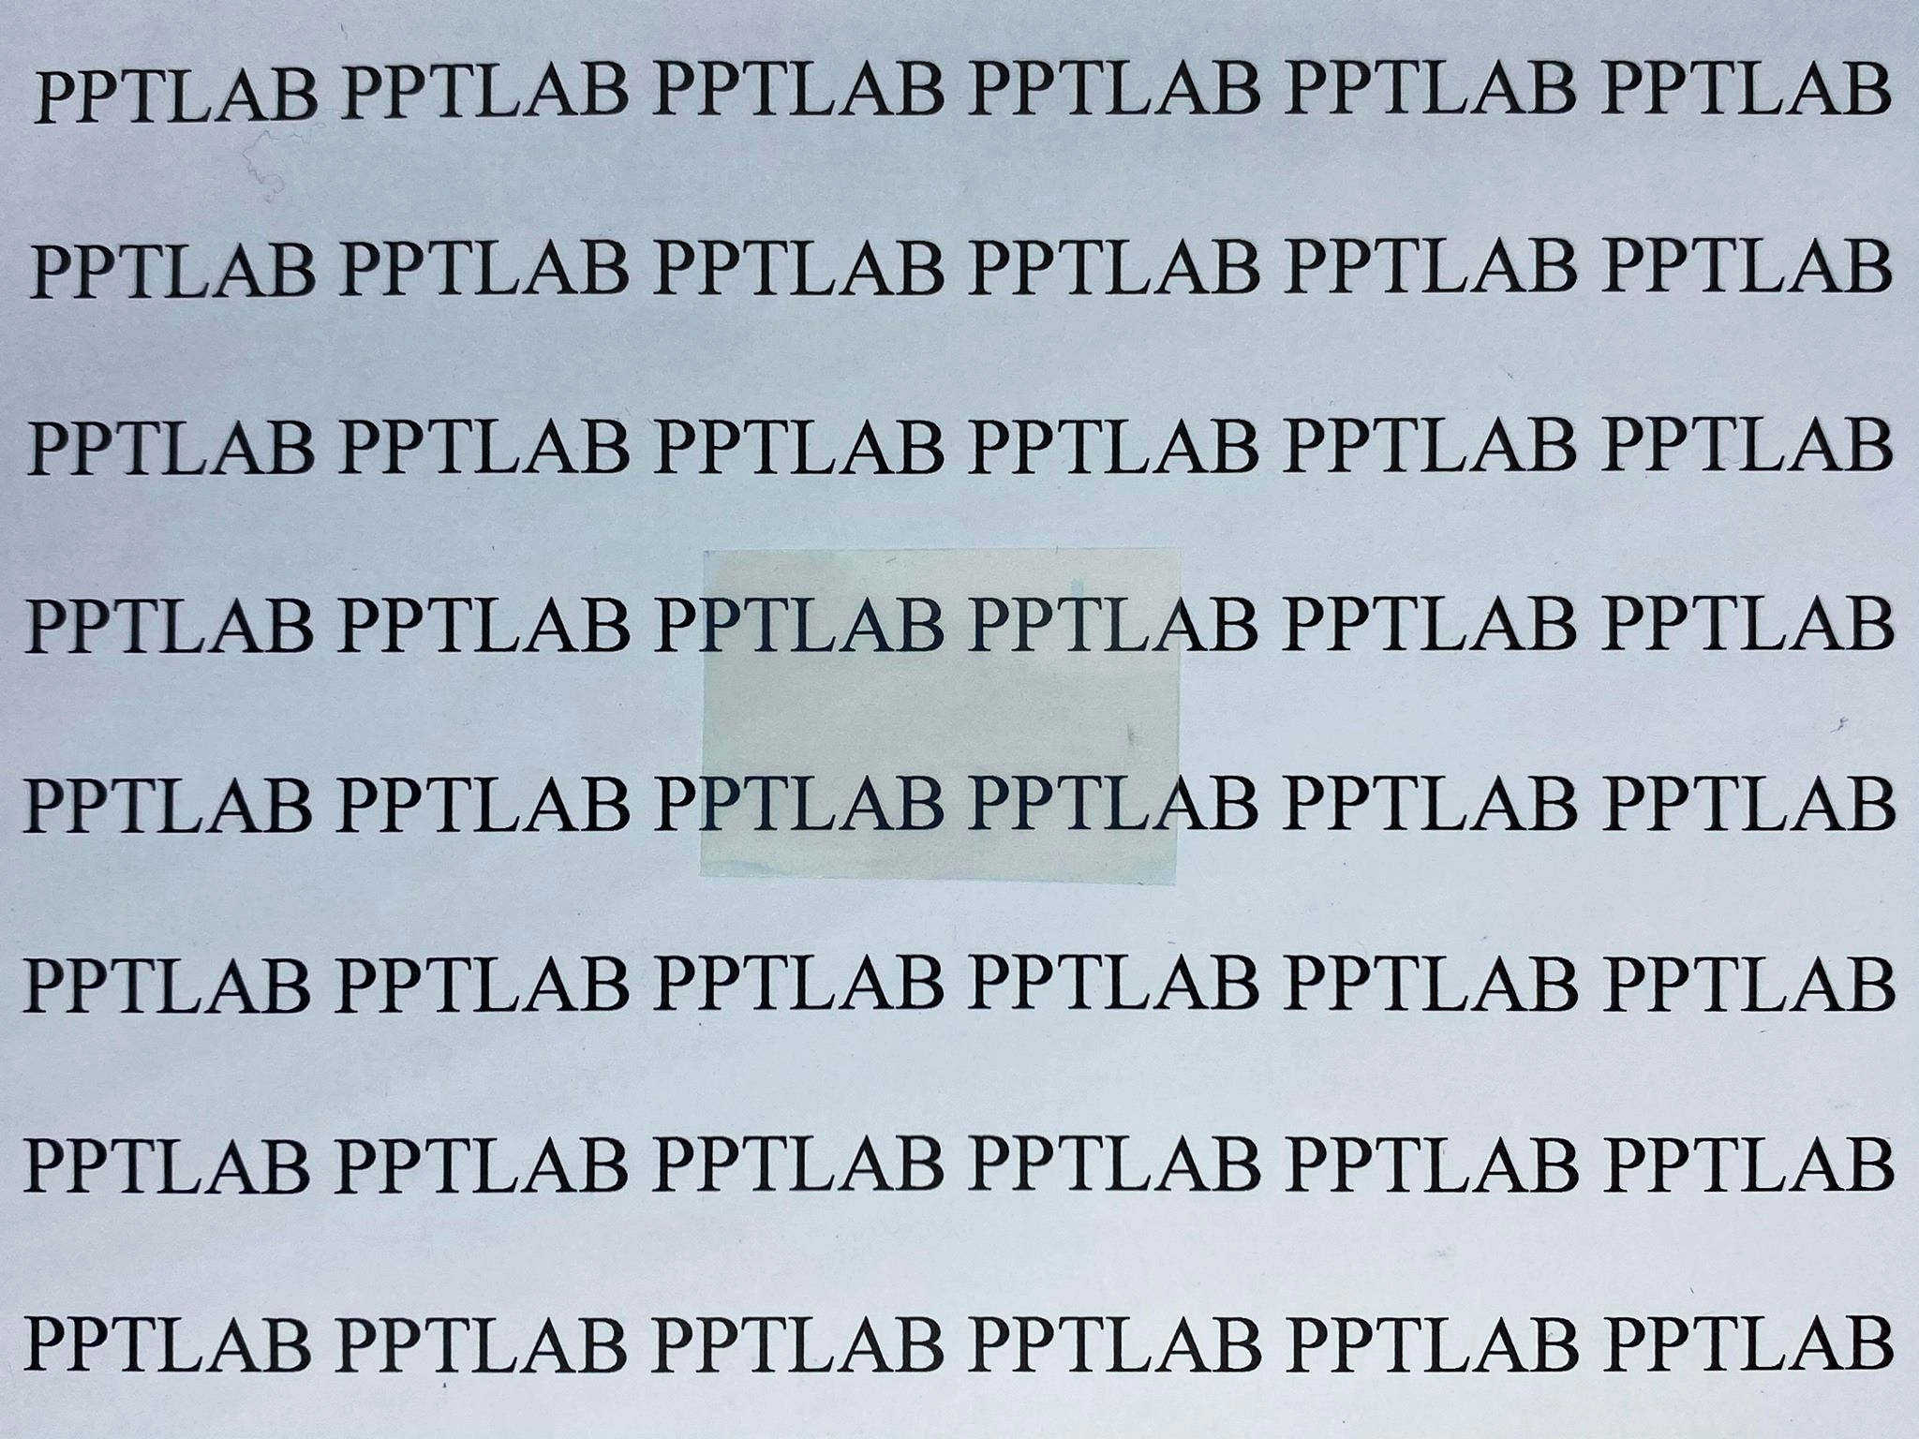

Figure 5. Image of as-prepared ITO film.



Figure 6. Light transmission of ITO film in visible light region.

Figure of merit (FOM) was an index to evaluate transparent conductive, the definition of FOM was as below, where T referred to transmittance and RS referred to sheet resistance.

$$Ф_{H }(FOM)=\frac{T^{10}}{R_{S}}$$

When FOM larger, indicating ITO film has higher transparency and lower sheet resistance. The FOM value of ITO-PET formed by blade coating solution-based process was 0.12, which is comparable with other previous researches as shown in Table 1.

Table 1. Comparison of FOM with other previous reference.

|  |  |  |  |  |
| --- | --- | --- | --- | --- |
| Reference | Rs (Ω/sq) | Transmittance (%) | FOM (10-2Ω-1) | Method |
| Sunde, T. O. L. et al. (2012) | 379 | 88 | 0.073 | Spin coating |
| Maruyama, T.; Kojima, A. (1988) | 573 | 96 | 0.116 | Dip coating |
| Ota, R. et al. (2003) | 100 | 70 | 0.028 | Dip coating |
| Lee, J. et al.  (2012) | 356 | 93 | 0.136 | Spin coating |
| This work | 500 | 92 (w/ PET)  95 (w/o PET) | 0.086  0.120 | Blade coating |

Bending test was also applied to test the duration of ITO-PET under multiple times bending as flexible electronics. In Fig 7, we observed that sheet resistance of ITO-PET in our research only increase by three time, but the sheet resistance of commercial ITO increased by over 100 times. With outstanding conductivity and transparency, we applied ITO-PET as electrode to formulate electrical double layer capacitor (EDLC). EDLC was formed in sandwich structure with two ITO-PET as electrode and LiCl/PVA as electrolyte. Cyclic voltammetry diagram in Fig 8. showed EDLC characteristic and good capacitance, indicating that ITO-PET from solution-based process could be applied in fabricating flexible electronics.



Figure 7. Bending test of ITO-PET in this research and commercial ITO-PET



Figure 8. Cyclic voltammetry diagram (scan rate= 0.01V/s)

**Conclusion**

In this research, we successfully fabricated ITO transparent conductive film by solution-based process and light sintering process. TODS and ball milling process could effectively disperse ITO nanoparticle and formulate well-dispersed ink. Suitable binder additive improved the adhesion of nanoparticles and substrate during blade coating and drying process. IPL was applied to sinter ITO nanoparticles as an effective sintering method for ITO films on polymer substrates. The best parameter for sintering was 1000 J divided into four small peaks (250 J each) repeated for four times pulses with 3000 ms time interval. ITO TCFs on PET substrate showed good conductivity (500 Ω/□) and transparency (>90 %). Also, the ITO film could withstand multiple times bending test with small sheet resistance change. For flexible electronics application, ITO conductive film could be applied as electrode for electrical double layer capacitor. This research simplifies fabrication process of ITO transparent conductive film through solution-based process and light sintering method, offering a new guideline for flexible electronics fabrication.