**Development of New Amorphous and Nanocrystalline Metallic Foils for Use in Energy-efficient Devices**

**Eric A. Theisen**

**Metglas, Inc.**

Presented at the 20th International Coating Science and Technology Symposium

September 20-23, 2020

Minneapolis, MN, USA

**Abstract:**

Fe-based amorphous and nanocrystalline soft magnetic alloys have been studied for decades for use in applications including high efficiency electrical distribution, power conditioning and advanced motor designs. Rapid quenching through the planar-flow melt spinning (PFMS) casting method is required to achieve the thin metallic glass (TMG) structure and the high cooling rates needed limit the foil thicknesses to less than 100 microns. Nanocrystalline alloys are obtained through a devitrifcation process in a controlled heat treatment step after the precursor amorphous foil has been cast. The underlying phyics of the TMG processing is compared to other conventional thin film processes. The next generation of amorphous and nanocrystalline alloys in develpoment today are also discussed.

**Introduction:**

Fe-based amorphous and nanocrystalline soft magnetic alloys are commonly used in many industrial products [1, 2]. This overview focuses on PFMS of Fe-based amorphous foil and the precursor amorphous foil that is annealed into the nanocrystalline state. Energy efficient transformers are the largest volume application for Fe-based amorphous foil. The ductile amorphous foils are stacked, cut to length and formed into a wound distribution transformer core. Many studies have focused on the optimum conditions to minimize the core loss deterioration and excitation power associated with forming and annealing the transformer cores [3, 4].

Nanocrystalline alloys are emerging as the premier products for medium to high frequency applications such as saturable reactor cores, inductors and switch-mode power supplies [5]. Nanocrystalline devices are made from foil that is typically cast fully amorphous and then formed into a tape wound or block core shape. The core is annealed above the onset crystallization temperature to achieve the nanocrystalline structure and then typically impregnated with a dielectric glue to insulate the laminations [6]. The mechanical brittleness of the foil after the nanocrystallization step prevents one from annealing the foil first and then forming it into a core. Tape wound or stacked core shapes are the most common method to form an electrical component out of foil. However, other methods include crushing the nanocrystalline foil into a powder or flake, then presing and sintering the material to form more complicated geometric shapes [7].

**Planar-flow Melting Spinning Process:**

The PFMS process is used extensively to produce amorphous foil. A schematic of the process is shown in Figure 1. Molten metal held in a ceramic crucible flows by applied head pressure through a nozzle onto a rotating quenching wheel. The linear wheel speed, the applied pressure, the nozzle breadth and the gap spacing between the nozzle and the wheel are the primary control parameters for the PFMS process. Figure 2 shows the contact zone where a molten metal puddle bridges the region between the nozzle and the wheel. The process has fundamental stability limits related to the capillary pressure at the upstream meniscus and have been detailed elsewhere [8, 9].



**Figure 1:** Schematic of the PFMS process.

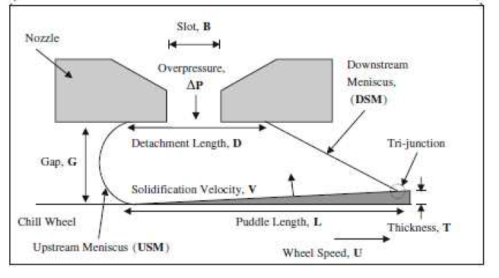

**Figure 2:** Schematic of the contact zone between the nozzle and wheel in the PFMS process.

The PFMS process has many geometric similarities to other types of coating flow processes. Table 1 lists typical process paratemeters, material properties for an FeBSi alloy and dimensionaless groups associate with the PFSM process. Inertial and surface tension forces balance in the contact zone making the PFMS process different from the viscous forces that are commonly associated with coating flows.

High heat transfer rates also distinguish PFMS from conventional coating flows. Cooling rates on the order of 105 C/s are required to suppress crystallization and produce a fully amorphous foil. The critical cooling rates are stongly dependent on the chemical composition of the alloy. Boron and silicon are added to the iron to improve the glass forming ability for the transformer core alloy. Bulk metallic glasses (BMGs) show amorphous structure over length scales on the order of centimeters and require lower cooling rates to suppress crystallization. BMGs use specific mixtures of different sized elements to act as a steric hindrance to prevent crystalization. TMGs utilize high cooling rates and are limited to thicknesses of less than ~ 50 microns in the heat extraction direction.

**Table 1**: Process parameter and matrial properties that yield key dimensionless groups for PFMS.



**Soft Magnetic Amorphous Foil Properties:**

The commercially available Metglas®2605SA1 alloy has long been used in high efficiency transformers and other power electronic applications. The foil has a saturation induction of 1.56 T and most transformers designed with it have an operating induction of 1.35 T. Conventional Si-steel laminations have higher saturation induction levels (~1.8-2.0 T) but also have higher core losses due to their crystalline structure and the increased thickness contributing to hysteresis and eddy current losses respectively. Fe-Co based amorphous alloys have saturation levels of 1.8 T but they are prohibitively expensive as a transformer core material. Table 2 shows the typical magnetic properties of various amorphous and nanocrystalline alloys compared with an M3 Si-steel. Note that amorphous foil is typically ten times thinner than Si-steel laminations. The core losses depend on frequency and induction levels whereas Table 2 only shows the DC coercivity. (Note that the high saturation nanocrystalline alloy is not commercially available today and the properties are given elsewhere [10].) While the coercivity and core losses of an amorphous transformer are only a fraction of a similarly rated Si-steel based transformer, the lower operating induction requires a larger core size. The footprint of an amorphous transformer has historically been larger than a conventional transformer but that is changing because efficiency regulations have forced transformer designs to operate at lower induction levels [11].

**Table 2**: Magnetic properties of various amorphous and nanocrystalline alloys compared with M3 Si-steel.

|  |  |  |  |  |  |
| --- | --- | --- | --- | --- | --- |
| **Alloy Designation** | **Saturation Induction (T)** | **Coercivity (A/m)** | **Stacking factor (%)** | **Thickness (microns)** | **Chemistry** |
| 2605SA1 | 1.56 | 1.2 | 88 | 23 | FeBSi |
| 2605HB1M | 1.63 | 1.1 | 89 | 25 | FeBSi |
| 2605CO | 1.8 | 3.0 | 85 | 25 | FeCoBSi |
| FINEMET | 1.2 | 1.0 | 75 | 16 | FeBSiNbCu |
| **Other alloys** |  |  |  |  |  |
| M3 Si-steel | 2.0 | 6.9 | 96 | 200-300 | FeSi |
| High Sat Nano* | 1.75 | 3 | 85 | 25 | FeBSiCu |

The stacking factor of Si-steel laminations can be near 96% due to the many rolling stages required to reduce the material thickness. Amorphous foil is directly cast from the molten stage to the rapidly quenched 25 microns thick foil and is not subsequently rolled thinner. The stacking factor of an amorphous core is determined by the flatness of the foil and the surface roughness of the foil in the as-quenched state. The first generation amorphous foils had stacking factors near 80% which again require a larger overall sized core.

Two recent trends have changed with Fe-based amorphous foil that helps to reduce the core size and overall transformer size. The first is a continuous improvement of the stacking factor of the foil from the first generation foils. Today the stacking factor is near 90% for amorphous foil. This allows for more volume of core material to fit into a smaller size. The second factor is the introduction of the advanced amorphous Metglas®2605HB1M foil with a saturation induction of 1.63 T [12]. The higher saturation allows for a further reduction in the core size. Typically, an HB1M amorphous core based transformer has an operating induction level of 1.42 T. This slightly increases the core loss but significantly reduces the overall transformer size. Figure 3 shows the core losses of an HB1M amorphous core to an M3 Si-steel core.



**Figure 3**: Typical values of core loss for an M3 grade Si-steel core and an HB1M based amorphous core as a function of induction level while operating at 60 Hz.

**Amorphous Transformer Core Processing:**

Amorphous foil is only 25 microns thick and therefore requires special processing to form into a transformer core. The standard method used to form cores starts by taking five amorphous spools and spinning them into a single five-ply spool as shown in Figure 4a). Three of the five-ply stacks are then fed together into a cutting machine that results in a fifteen-layer stack that is similar to a Si-Steel layer in thickness. Figure 4b) shows a schematic of the process where the cutting machine increments the cut length on each cut to account for the increasing outer layer of the core.



**Figure 4**: a) Five spools being feed toegether into a five layered feed spool. b) Three layered spools being fed together into a cutting machine to form a laced distribution transformer core.

Figure 5 shows the process of forming a laced distribution core. A protective Si-Steel sheet is placed on the inner and outer wraps of the core for stability. The cut layers are assembled into a laced core by clamping the stack and overlapping the step joints. Inner and outer mandrels are used to form the stacked foil into a rigid core. The core is then banded and annealed under a longitudinal magnetic field. An epoxy coating is applied to each face of the core after the annealing process. This step adds mechanical rigidity to the core. The section of the core with the overlap lacings is not glued so that the core can be opened to insert the coil windings, as shown in Figure 5 d).

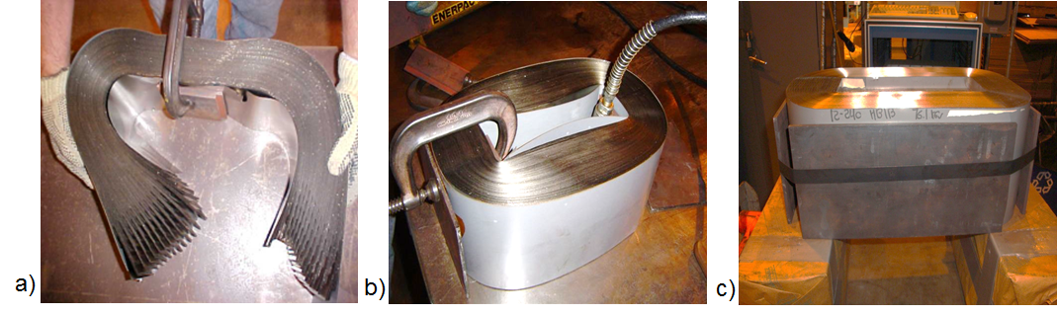 d) 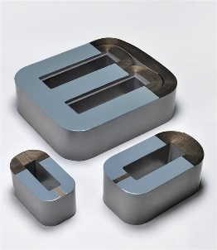

**Figure 5**: Images of a) cut to length foil stacks being formed into closed core, b) joints are closed and clamped into place, c) mandrels that are put in place when the core is banded and d) a finished core with epoxy side coating applied.

**Advanced Nanocrystalline Alloys:**

The conventional nanocrystalline alloys generally follow the FINEMET**®** type chemistry of FeBSiNbCu. These alloys are cast as fully amorphous foils and then annealed through conventional methods to achieve the nanocrystalline structure [13]. The conventional process implies winding the foil into a toroid or tape wound core and then annealing in a furnace at a temperature above the onset crystallization event such that one achieves the desired nanocrystalline structure. The nanocrystalline electronic components have been available for many years but are currently being widely adopted commercially for emerging high frequency applications.

Recently, nanocrystalline foil has been produced domestically in the U.S. up to 170 mm wide [14]. Traditionally FINEMET type foils have only been available at 60 mm in width. These foils are then slit to 10 or 20mm and wound into electric components. The wide nanocrystalline foil, Metglas**®**FT-3W, can be fabricated into much larger components that eliminate the need for multiple stacked core components for wide applications.

The saturation induction of FINMET type alloys is limited to ~ 1.2 T in part because of the reduced Fe content inherent to the chemistry. This is above the level of many ferrites or Co-based amorphous alloys but significantly below Fe-based amorphous or Si-steels. The FINEMET chemistry includes Cu to help promote nucleation of the nanocrystalline phase during the furnace anneal and Nb to limit the grain growth to a uniform size distribution near 20 nm.

Many recent studies have focused on increasing the saturation induction to levels of 1.7 – 1.9 T of nanocrystalline alloys through a combination of chemistry modification and annealing conditions [10, 15-19]. The Fe content is increased by lowering the Nb content which helps to increase the induction level. The general chemistry for these higher induction level alloys is FeBSiCu with other trace elements. These alloys are cast into a fully amorphous state or may have nanocrystalline seed particles in the as-cast state. Then a rapid heat treatment is done to form the final nanocrystalline material. However, this type of heat treatment is not compatible with the current methods of heat treating amorphous or nanocrystalline cores and this is an area of active research.

**Conclusions:**

Progress in new amorphous magnetic alloys with higher saturation induction and higher stacking factor have led to smaller electrical distribution transformers that are economically competitive with Si-steel based transformers. The next generation of amorphous Metglas 2605HB1M foil is being adopted in distribution transformers globally. Nanocrystalline foils based on the FINEMET chemistry are increasingly being adopted as components for high frequency applications. New annealing methods are being developed to tailor the magnetic performance for specific applications. High induction nanocrystalline alloys have also been developed and the fabrication methods for integrating these alloys into electrical components are being studied.

**References:**

1. C. Smith, in *Rapidly Solidified Alloys*, edited by H. Liebermann, (Marcel Dekker, New Delhi, 1993) pp. 617-663.

2. R. Hasegawa, *J. Magn. Magn. Mater*., 304, 187, (2006).

3. D. Li, L. Zhang, G. Li, Z. Lu, and S. Zhou, *Prog. Nat. Sci., Mat. Int*., **22** 3, 244 (2012).

4. D. Raybould, M. Meola, R. Bye and S. Das, *Mat. Sci. Eng*., A241, 191, (1988).

5. M. Willard and M. Danill, in *Handbook of Magnetic Materials, Vol 21*, edited by K. Buschow, (Elsevier, North Holland, 2013) pp. 173-342.

6. B. Cougo, A. Tuysuz, J. Muhlethaler and J. Kolar, in *Increase of Tape Wound Core Losses Due to Interlamination Short Circuits and Orthogonal Flux Components*, ( IECON 2011, 37th Ann. Con. IEEE Ind. Ecect. Soc, 2011) pp. 1372-1377.

7. X. Wang, C. Lu, F. Guo, Z. Lu, D. Li and S. Zhou, *J. Magn. Magn. Mater*. 324, 2727, (2012).

8. P.H. Steen and C. Karcher: Ann. Rev. Fluid Mech., 1997, vol. 29, pp. 373-97.

9. Byrne, C., Weinstein, S., and Steen, P.H., Chem. Eng. Sci. 61, 8004–8009 (2006).

10. M. Ohta and R. Hasegawa, IEEE Trans. Mag. 53, 2, (2017).

11. B. Kennedy, *Energy Efficient Transformers*, (McGraw Hill, New York, 1998), p. 127.

12. K. Takahashi, D. Azuma and R. Hasegawa, *IEEE Trans. Mag*. 49, 4001, (2013).

13. G. Herzer, in *Handbook of Magnetic Materials, Vol 10*, edited by K. Buschow, (Elsevier, North Holland, 1997) pp. 415-462.

14. High Performance Nanocrystalline Foil Product Release Sheet (2015). Available at: http://www.metglas.com/products/nanocrystallinefoil/... (accessed 2 May 2017).

15. M. Ohta, and Y. Yoshizawa, *J. Phys. D., App. Phys*, 44, 1, (2011).

16. P. Sharma, X. Zhang, Y. Zhang, A. Makinol, *Scripta Materialia*, 92, 6, (2015).

17. B. Zang, R. Parsons, K. Onodera, H. Kishimoto, A. Kato, A. Liu and K. Suzuki, *Scripta Materialia*, 132, 68, (2017).

18. H. Jung, M. Stoica, S. Yi, D. Kim and J. Eckert, *Met. Mat. Trans. A*, 45A, 2415, (2015).

19. A. Leary, P. Ohodnicki and M. McHenry, *JOM*, 64, 772, (2012).