EFFECT OF TIME-DEPENDENT RHEOLOGY IN SMALL SCALE FLOW

Carlos Sanchez-Perez*, Danmer Maza, Paulo R Souza Mendes, Marcio Carvalho, PUC-Rio, Brazil

Presented at the 20th International Coating Science and Technology Symposium
September 20-23, 2020
Minneapolis, MN, USA

ISCST shall not be responsible for statements or opinions contained in papers or printed in its publications.

Extended Abstract:
Abstract

Different type of fluids used in industry have a complex rheological behavior, including those who exhibit time-dependent behavior. Our particular interests are thixotropic fluids, whose viscosity decreases as time increases under constant shear. Traditionally, this kind of fluids has theoretically been characterized by a structuring factor that measures indirectly the breaking and building-up of internal microstructures. Nevertheless, we are using a rheological model based on a more meaningful parameter: fluidity (reciprocal of viscosity). The latter is also related to the micro structuration of the fluid.
A numerical model of thixotropic fluid flow through a capillary is presented here. The complex flow is modelled by the continuity and momentum equations coupled with two additional differential equations. One is a scalar evolution equation for the fluidity, while the other is a tensorial equation that relates stress with shear rate. The complete equation system was solved by using the Galerkin and Petrov-Galerkin / Finite Element Method. Fluidity fields and velocity profiles are presented. They show the changes inside of the capillary, as well as, the impact of the behavior index.

Keywords: Thixotropy, fluidity, capillary, Finite Element Method.

Introduction

There are interesting and important fluids in industry and other human activities, that differ from the “ideal” Newtonian behavior. The mechanical behavior of structured fluids, such as polymeric solutions, waxy oils, muds, pharmaceutical & cosmetic products, paints, clay suspensions, processed food, among others (Mewis & Wagner, 2009; Souza Mendes, 2009), cannot be described by a simple linear relationship between stress and rate of strain. Actually, their macroscopic rheological properties rely on their microscopic structure (Pritchard et al, 2016). As a result, their rheology also has time dependency.

Time-dependent fluids are subdivided into: thixotropic and anti-thixotropic (or so-called rheopectic in some literature). Specifically talking about thixotropic phenomenon, it is characterized by a gradual break down of the fluid internal microstructures under shear. On the other hand, these microstructures eventually build up when the flow is ceased. As a result, thixotropy is a reversible process but the microstructure change takes time (Barnes, 1997).

Most of thixotropic models have a semi-empirical nature (Mewis & Wagner, 2009). They are based two equations: the stress ($σ$) as a function of shear rate evolution ($\dot{φ}(t)$), as shown in equation 1 and a kinetic-like equation, as described in equation 2. The latter shows the evolution a microstructure parameter (λ), where λ = 1 represents the maximum structuring level while λ = 0 represents the minimum one.

$σ\left(t\right)=σ_{y}\left[λ(t)\right]+η_{λ}\left[λ\left(t\right),\dot{φ}(t)\right]\dot{φ}(t)+η_{λ=0}\left[\dot{φ}(t)\right]\dot{φ}(t)$ (1)

$\frac{dλ}{dt}=-k_{1}{\dot{γ}}^{a}λ^{b}+k_{2}{\dot{γ}}^{c}{\left(1-λ\right)}^{d}$ (2)

The first term in the right-hand side of eq. (1) is the yield stress, while η_{λ} and η_{(λ=0)} are the structural and residual viscosities respectively. k₁, k₂, a, b, c and d are constants of the kinetic evolution equation.

Souza Mendes (2009), Souza Mendes & Thompson (2012; 2013) and Souza Mendes et al. (2018) have used mechanical analogues, as shown in figure 1, with the intention of unifying thixotropic models. In addition, Souza Mendes et al. (2018) replaced the microstructure parameter (λ) for a more meaningful parameter: fluidity. Actually, the latter is the reciprocal of viscosity. Furthermore, this rheological model is based on parameters obtained experimentally. Previous works like Fredrickson (1970), proposed fluidity use instead of structuring factor as well. As a result, we decided to employed the model by Souza Mendes et al. (2018) in the present work.

Besides the thixotropic characterization, measurement and modelling; there are many challenges in incorporating these models into actual flow simulations. In the case of mixers, Barnes (1997) argues that the simulations are relatively easy. Actually, the mixer is treated as a viscometer running at the same shear rate as the average shear rate in the mixer. On the other hand, the same author says that the simulation of flows in pipes is very complicated, especially in short ones where steady-state condition is not reached. He also argues that the analysis is complex and extensive numerical methods are required. For instance, Moises et al (2018) used the volume control method to simulate start-up thixotropic flow in a horizontal pipe. Although Sochi (2010) and others give some hints and identify issues to simulate thixotropic flows into porous media and small scale, the research about it is much more limited. As a result, this is one of the main motivations of this work.

Mathematical model and methodology
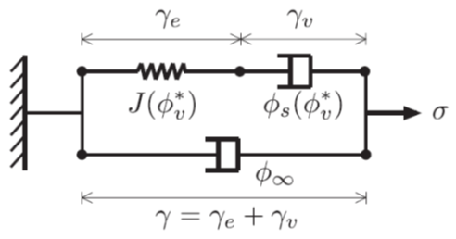
Figure 1. Mechanical Analogue of Thixotropic fluids (Souza Mendes et al., 2018)

The mechanical analogue shown above is suitable for viscoelastic thixotropic fluids. Therefore, a tensorial Oldroyd-B-like differential equation (Equation 3) represents the model above. $ϕ_{v}^{*}$ is the normalized fluidity, which varies from 0 to 1. Then, this parameter is related to $ϕ_{0}$ and $ϕ_{∞}$ (As shown in equation 5); which are respectively the fluidities at maximum and minimum structuring level. J is the compliance, which was substituted by $θ_{S}$ and $θ_{∞}$ (Relaxation and retardation times respectively) in the tensorial equation (3).

$\dot{γ}+θ_{∞}\left(ϕ_{v}^{*}\right)\overset{∇}{\dot{γ}}=\left[\left(ϕ_{∞}-ϕ_{0}\right)ϕ_{v}^{*}+ϕ_{0}\right]\left[σ+θ_{S}\left(ϕ_{v}^{*}\right)\overset{∇}{σ}\right]$ (3)
Where: $\overset{∇}{M}=\frac{DM}{Dt}+M∙\left(∇\text{v}\right)-{\left(∇\text{v}\right)}^{T}∙M$ (4)
$ϕ_{v}^{*}=\frac{ϕ_{v}-ϕ_{0}}{ϕ_{∞}-ϕ_{0}}$ (5)

The operator $D/Dt$ represents a material time derivative, while $ϕ_{0}$ is usually approximated to zero. It is also assumed that the normalized fluidity, $ϕ_{v}^{*}$, is governed by the evolution equation shown as follows:

$\frac{Dϕ_{v}^{*}}{Dt}=f\left({ϕ_{eq}^{*}\left(σ\right),ϕ}_{v}^{*}\right)$ (6)

$ϕ_{eq}^{*}$ (See equation 7) is the normalized fluidity at equilibrium state, where K and n are the consistency and Power-law indexes respectively. The function $f\left({ϕ_{eq}^{*}\left(σ\right),ϕ}_{v}^{*}\right)$ is a function by parts obtained semi-empirically by Souza Mendes et al (2018), as shown in equation (8). The parameters s, t_{a} and t_{c} are a scalar exponent, avalanche and construction times respectively.
$ϕ_{eq}^{*}=\frac{\left(1/σ\right){\left[{\left|σ-σ_{y}\right|}/K\right]}^{1/n}}{\left(ϕ_{∞}-ϕ_{0}\right)+\frac{1}{σ}*{\left[{\left|σ-σ_{y}\right|}/K\right]}^{1/n}}$ (7)

$f\left({ϕ_{eq}^{*},ϕ}_{v}^{*}\right)=\left\{\begin{aligned}\frac{s}{t_{a}ϕ_{eq}^{*}}{\left(ϕ_{eq}^{*}-ϕ_{v}^{*}\right)}^{\frac{s+1}{s}}{ϕ_{v}^{*}}^{\frac{s-1}{s}} 0<ϕ_{v}^{*}≤ϕ_{eq}^{*} \\ \\ -\frac{\left(ϕ_{v}^{*}-ϕ_{eq}^{*}\right)}{t_{c}} { ϕ}_{eq}^{*}<ϕ_{v}^{*}≤1 \end{aligned}\right.$ (8)

We are preliminarily studying thixotropic flows at steady-state condition. Consequently, equation (3) becomes much simpler, since $θ_{S}$ and $θ_{∞}$ tend to be zero (As stated Souza Mendes et al 2018). Then, we are considering that $ϕ_{0}$ tends to be zero as well. As a result, equation (3) takes the form of a Newtonian generalized fluid equation:
$\dot{γ}=ϕ_{v}*σ$ (9)

Regarding to equation (6), the transient term is discarded. As a result, we obtained:

$\text{v}∙∇ϕ_{v}^{*}=f\left({ϕ_{eq}^{*}\left(σ\right),ϕ}_{v}^{*}\right)$ (10)

There is still an issue with the continuity of $f\left({ϕ_{eq}^{*}\left(σ\right),ϕ}_{v}^{*}\right)$, which was solved by using a smooth Heaviside function.

The velocity v and pressure p fields of the incompressible flow are governed by the continuity $∇∙\text{v}=0$, and momentum, $ρ_{i}( \text{v}∙∇\text{v})-∇∙T_{i}=0$, equations. Where ρ is the liquid density. The total stress tensor for Newtonian liquids is $\text{T}=-p\text{I}+μ[∇\text{v}+{(∇\text{v})}^{\text{T}}]$, where μ is the liquid viscosity. With appropriate boundary condition the system of equation are solver by using the Galerkin and Petrov-Galerkin / Finite Element Method with quadrilateral finite elements.

Results and Discussion

The results were obtained at P_{IN} = 0.1 MPa, P_{OUT} = 0; and K = 1 Pa.s^{n}, n = 0.32, $σ_{y}$= 6 Pa, $θ_{∞}$ = 64.1 (Pa.s)⁻¹. The boundary condition, for the fluidity field, at the entrance was set at $ϕ_{v}$ = 1 (Pa.s)⁻¹. This problem was computed by using a concentrated mesh close to the wall with 1350 elements. Figure 2 shows preliminary results of the fluidity field along the capillary at different behavior indexes, n = 0.9 and n = 0.32.

The second fluidity field shows how this property varies much more very close to the wall, where the fluid is under much more stress. However, the effect of the wall on the fluidity is propagated as the fluid goes further into the capillary. When the behavior index is changed to a lower value, the fluidity field has a significant change as the corresponding velocity profile; as shown in Figure 3. The maximum velocity, measured at the symmetry line, of the suspension with n = 0.32 is larger than using n = 0.9. The shape of the velocity profile also changes as a function of the behavior index.

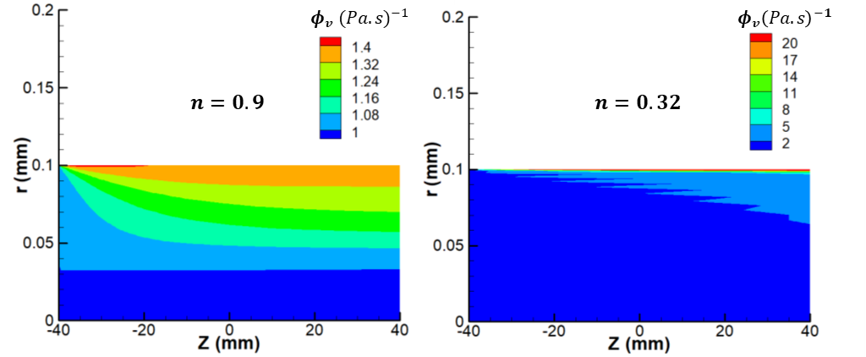
Figure 2. Fluidity fields flowing into a capillary with: a) n = 0.9 and b) n = 0.32.

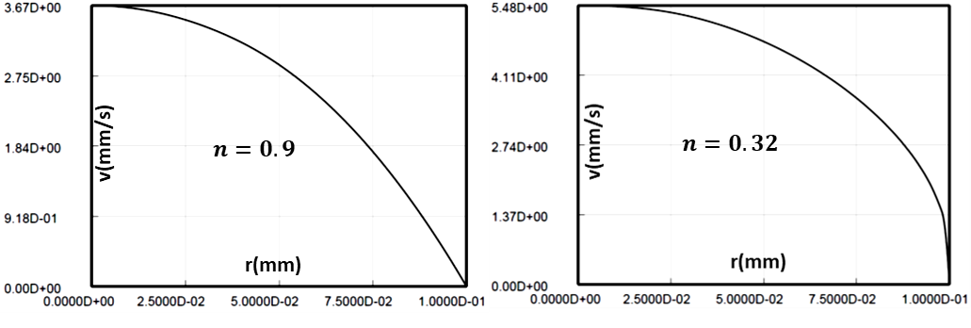
Figure 3. Effect of the behavior index on velocity profile for thixotropic fluids.

Conclusions

A novel rheological model, based on fluidity, was used. The equation system consisting of continuity, momentum and fluidity equations was solved by using the Galerkin and Petrov-Galerkin / Finite Element Method. As a result, fluidity fields and velocity profiles were obtained for suspensions into a capillary. Most changes in fluidity field were noticed close to the capillary walls. Simulations in other capillary configurations are planned in future works, like capillary with constriction. Furthermore, experimental results are expected in the near future; in order to validate the theoretical model.

References
- Barnes, H. (1997), Thixotropy - A Review, J. Non-Newtonian Fluid Mech., 70: 1-33
- Fredrickson, A.G. (1970), A model for thixotropy of suspensions, AIChEJ, 16:436-441
- Mewis, J., Wagner, N. (2009), Thixotropy, Adv. in Colloid and Interface Sci., 147-148: 214-227
- Moises, G.V.L., Alencar, L.S., Naccache, M.F. & Frigaard, I.A. (2018), The influence of thixotropy in start- up flow of yield stress fluids in a pipe, J. Petroleum Sci. and Eng., 171:794–807
- Pritchard, D., Wilson, S.K. & McArdle, C.R. (2016), Flow of a thixotropic or antithixotropic fluid in a slowly varying channel: The weakly advective regime, J. Non-Newtonian Fluid Mech., 238:140-157
- Sochi, T. (2010), Non-Newtonian flow in porous media, Polymer, 51: 5007-5023
- Souza Mendes, P.R. (2009), Modeling the thixotropic behavior of structured fluids, J. Non-Newtonian Fluid Mech., 164: 66-75
- Souza Mendes, P.R. (2011), Thixotropic elasto-viscoplastic model for structured fluids, Soft Matter, 7:2471-2483
- Souza Mendes, P.R., Abedi, B. & Thompson, R.L. (2018), Constructing a thixotropy model from rheological experiments, J. Non-Newtonian Fluid Mech., 261:1-8
- Souza Mendes, P.R. & Thompson, R.L. (2012), A critical overview of elasto-viscoplastic thixotropic modelling, J. Non-Newtonian Fluid Mech., 187-188: 8-15
- Souza Mendes, P.R. & Thompson, R.L. (2013), A unified approach to model elasto-viscoplastic thixotropic yield-stress materials and apparent yield-stress fluids, Rheol. Acta, 52:673-694

LMMP Group, PUC-Rio, Rio de Janeiro 22451-900, Brazil, +55 (21) 3527-2531 csanchez@lmmp.mec.puc-rio.br
LMMP Group, PUC-Rio, Rio de Janeiro 22451-900, Brazil, +55 (21) 3527-2531 danmer@lmmp.mec.puc-rio.br
Rheology Group (GReo), PUC-Rio, Rio de Janeiro 22451-900, Brazil, +55 (21) 3527-1177 pmendes@puc-rio.br
LMMP Group, PUC-Rio, Rio de Janeiro 22451-900, Brazil, +55 (21) 3527-2531 msc@puc-rio.br

