Roll-to-Roll Direct Coating of Catalyst Inks on Membrane Films: Progress and Challenges

Janghoon Park, Zhenye Kang, Guido Bender, Michael Ulsh, Scott A. Mauger

Chemistry and Nanoscience Center, National Renewable Energy Laboratory, 15013 Denver West Parkway, Golden, CO 80401, USA

Presented at the 20th International Coating Science and Technology Symposium
September 20-23, 2020
Minneapolis, MN, USA

ISCST shall not be responsible for statements or opinions contained in papers or printed in its publications.

Extended Abstract (ten page maximum):
To enable the U.S. Department of Energy’s hydrogen production cost goal of $2/kg, high volume manufacturing processes will be required to lower manufacturing costs [1]. The membrane electrode assembly (MEA) is the key component of low temperature water electrolyzers. The typical MEA configuration is the catalyst coated membrane (CCM). Typically, the CCM has been fabricated by continuous roll-to-roll (R2R) coating of catalyst inks on a decal film (e.g. Teflon, polyimide, etc.) followed by a hot lamination process of the catalyst layer to the membrane [2]. To reduce the process costs and improve the process efficiency, we propose direct coating of the catalyst ink onto the membrane using slot-die and gravure techniques [Fig. 1].
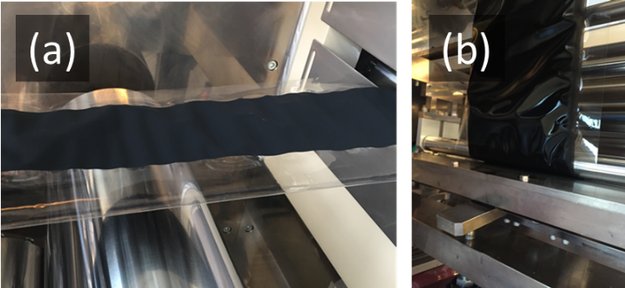
Fig. 1. R2R production of CCMs: (a) slot-die coated iridium oxide catalyst layer on Nafion 117 membrane. (b) gravure coated platinum/carbon catalyst layer on Nafion 115 membrane.

There are many challenges with this methodology, both in the coating process as well as with web handling, because of membrane swelling due to solvent absorption from the catalyst ink. To understand this process, we investigate the membrane-ink interaction through a contact angle measurement and verify the coatability of various ink formulations through lab-scale coatings.
The data in Fig. 2 shows that wetting properties on the membrane change depending on the 1-propanol content in the water/1-propanol mixture, and that dispersibility is also affected when preparing catalyst ink. Interestingly, the 50% 1-propanol mixture shows the fastest penetration into the membrane, resulting in faster membrane distortion. The absorption characteristics of the solvent into the membrane are identified by a direct absorption method in addition to the contact angle measurement. In addition, the change in the membrane mechanical properties during swelling is analyzed from the web handling perspective.
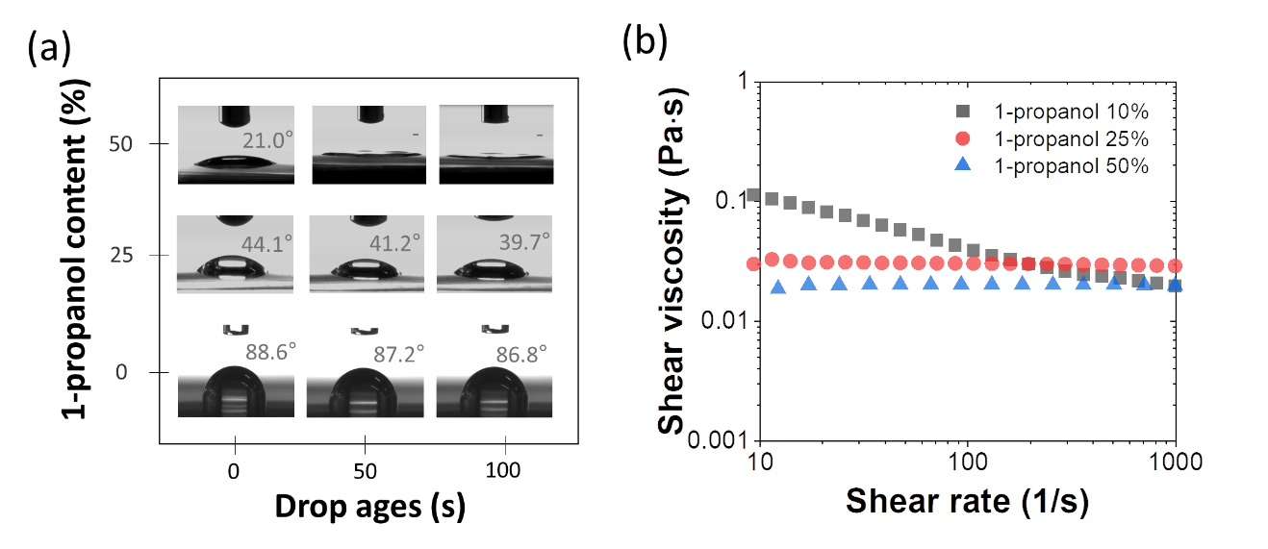
Fig. 2. (a) contact angle measurements for different 1-propanol contents in water/1-propanol mixtures on Nafion 212 membrane as drop aging. (b) Steady-shear viscosity data for different 1-propanol contents of 30wt.% IrO₂ dispersions.

Finally, we discuss the R2R coating results and show the resulting electrochemical performance of the prepared CCMs. The R2R-based CCM shows comparable performance to the existing lab-scale spray-coated CCMs. Very promisingly, compared to our standard spray-coated CCMs, the fast production rate in this R2R process is about 500 times the throughput. In conclusion, the process guidelines and advances in understanding gained from this study are expected to have significant impact in many additional electrochemical applications such as fuel cells and CO₂ electrolysis, with the advantages of less process steps (compared to decal transfer method) and high throughput.
References
[1] Miller, Eric L., et al. "US Department of energy hydrogen and fuel cells program: progress, challenges and future directions." MRS Advances 1.42 (2016): 2839-2855.
[2] Wei, Zhaoxu, et al. "High performance polymer electrolyte membrane fuel cells (PEMFCs) with gradient Pt nanowire cathodes prepared by decal transfer method." International Journal of Hydrogen Energy 40.7 (2015): 3068-3074.

Acknowledgements
This work was authored by the National Renewable Energy Laboratory, operated by the Alliance for Sustainable Energy, LLC, for the U.S. Department of Energy (DOE) under Contract No. DE-AC36-08GO28308. Funding provided by the U.S. Department of Energy, Office of Energy Efficiency and Renewable Energy, Hydrogen and Fuel Cell Technologies Office. The views expressed in the article do not necessarily represent the views of the DOE or the U.S. Government.

