SIMULATION OF SLOT-COATING OF NANOCELLULOSIC MATERIAL SUBJECT TO A WALL- STRESS DEPENDENT SLIP-VELOCITY AT DIE-WALLS

Fuaad Panikaveetil Ahamed Kutty¹, Martti Toivakka¹, Agne Swerin², Fredrik Lundell²
¹Åbo Akademi University, Turku, Finland
² Royal Institute of Technology KTH, Stockholm, Sweden

Presented at the 20th International Coating Science and Technology Symposium
September 20-23, 2020
Minneapolis, MN, USA

ISCST shall not be responsible for statements or opinions contained in papers or printed in its publications.

Introduction
Widespread industrial and academic interest in nanocellulosic materials as a bio-based alternative for food packaging is driven due to renewability, the abundance of cellulose, and proven barrier properties against oxygen, mineral oils, and grease. From an operative perspective, an accurate understanding of the flow and rheological properties of nanocellulosic materials is essential to control and optimize high throughput manufacturing and efficient automation of coating processes.
In coating applications, where the desired product is a thin film (either free-standing or on a substrate), control of rheological properties are directly relevant to the final product properties. For example in slot coating, the suspension rheology is critical for favourable coating processing conditions and will dictate the drying energy requirements, whereas the resulting spatial and orientation distribution of nanocellulosic particles will influence the final product characteristics. The distribution of nanocellulose fibrils in an aqueous suspension is extremely complex, and lead to distinct rheological characteristics. A fundamental phenomenon that contributes to the difficulty in obtaining an accurate flow model is the presence of a thin wall-bounded particle-depleted-layer of the order of a few microns where the shear is highly non-uniform. Some studies [1] suggest that this 'apparent slip' may arise due to particle migration as a resultant of the random Brownian motion and two competing forces: hydrodynamic interactions between the fibrils and the wall, and fibril-fibril interactions, while other studies argue that fibrils migrate from the high shear-rate, near-wall regions towards lower-shear bulk flow until the shear-rate gradients in are balanced by the concentration-gradients[2]. Although the effect of apparent wall-slip may not be directly relevant and can be neglected in lower concentrations, the contribution of nonlinear wall-slip becomes more critical as the solid-content is increased and must be addressed along with other essential modelling challenges stemming from the presence of yield stress and highly shear-thinning behaviour. Numerous approaches for modelling the effective-deficit in momentum- transfer resulting from the apparent slip layer have been suggested in the past; including molecular dynamics (MD) methods and Lattice Boltzmann methods (LBM). However, the most effective mode is to employ the traditional flow solving techniques, which discretize and solve the macroscopic Navier–Stokes (NS) equations on a continuum mechanics framework. The particle depleted layer is modelled as an infinitely thin layer and is effectively applied by replacing the no-slip boundary condition in the wall parallel directions by a wall-shear stress-dependent nonlinear Navier-slip condition. This approach is motivated by the knowledge that, provided there is an empirical model of the slip-behaviour from standard experiments, the model can provide the accurate stress and velocities at the wall without calculating the macroscopic particle interactions, which can be prohibitively expensive in an industrial scenario. The current work aims to provide a preliminary study of the mechanisms on how slip can influence the flow of nanocellulosic materials in realistic industrially applicable conditions. Precisely, herein, simulation results of slot-die flow for 3% Micro-Fibrillated-Cellulose (MFC) are presented in the knowledge of previously reported experimental data.

Numerical Methodology
A 2D computational domain and parameter space are carefully chosen based on previous experimental work by [3] as represented in Figure 1. The slot-die coating head placed at 3 o'clock position with the backing roll and slightly offset downwards from the centre of the backing roll. Such as arrangement facilitates to control the coat weight with the minimum gap (SWG) as the geometry between the coating head lips and the backing roll is convergent. In this mode, some material is metered off, gathered later and channelled to the inlet feed for reuse.
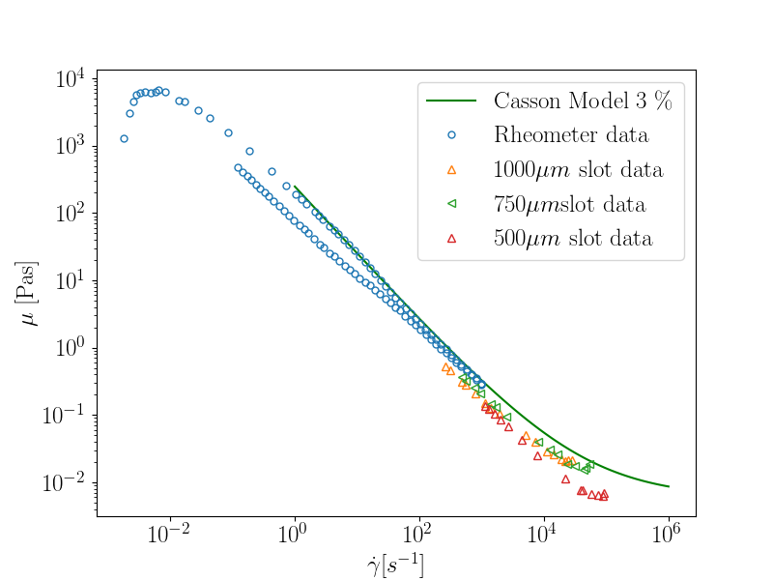
Figure 1. Left: Simulation geometry, boundary conditions., Right: The Casson rheology model employed with the existing experimental data.
Furthermore, this arrangement in the slot-die coating is beneficial compared to the pre-metered method as it allows to control the coat-weight independently of the feed flow-rate. Additionally, high flow-rates aids in overcoming the high yield-stresses faced in nanocellulosic materials. For simplicity, the substrate is considered to be a non-absorbing, no-slip smooth surface on the backing roll surface. A two-dimensional, laminar, steady-state flow field is assumed throughout the study. The governing partial differential equations (PDEs) for an incompressible, isothermal fluid can be expressed as the conservations of mass and momentum:

$$∇.U=0 ;$$
$$ρ ∂U/∂t+ρ∇.(UU)=-∇p+ρg+ρ∇.(ν∇U) .$$

Here, ρ is the density, U is the velocity field, t is the time, p is the pressure, g is the gravitational acceleration, and ν is the kinematic viscosity. The finite volume method based OpenFOAM framework is employed to discretize the system of PDEs resulting from the governing equations. The volume-of-fluid method [4] based interFoam solver is utilized to capture the development of the free-surface of the immiscible two-phase flow between the coating-fluid and air. The rheology of nanocellulose is numerically described using a Casson model, ($\sqrt{τ}=\sqrt{τ_{0}}+\sqrt{η_{p}\dot{γ}}$) which includes yield stress and the Casson model parameters ($τ_{0}=245$ Pa and $μ_{p}=0.006$Pas). These were obtained from slot viscometry measurements reported for 3% concentration of mechanically produced cellulose nanofibrils [5], by considering the nonlinear slip. From Fig 1, we can see that the effect of nonlinear slip becomes prominent at high shear rates. The slip velocity is modelled as a function of wall shear stress, and the relationship between the two quantities is implemented in OpenFOAM as a nonlinear power law:

$u_{s}=Sτ_{w}^{m}$.

The nonlinear slip parameters ($S=3.31$ and $m=4.63$) were also chosen from slot-rheometry experiments by systematically varying the slot-gap. All the solid walls in the computational domain were prescribed nonlinear slip boundary conditions except the coating substrate.

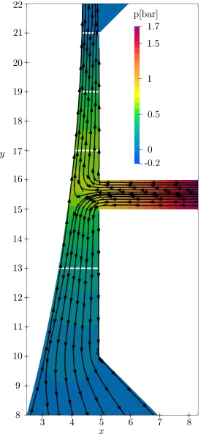
Figure 2. Representative streamlines and pressure distribution of the no-slip case with SWG=600 µm. The locations of the velocity distribution probes shown in Fig 3 are also highlighted.

Results
For studying the effect of wall-slip systematically, simulations were performed for four different slot-web gaps with SWG=300 µm, 600 µm, 1000 µm and 1200 µm, with both slip and no-slip boundary conditions. These cases constitute realistic coating gaps and results in the defect-free coatings in the corresponding experimental setup. Furthermore, the slot-die gap is kept at 1000 µm, with a web speed of 10 m/min (0.167 m/s) while the slot-die average inflow rate is fixed at 0.180 m/s. At the slot gap exit, the flow bifurcates into upward and downward flows driven by the pressure from the feed into the slot die.

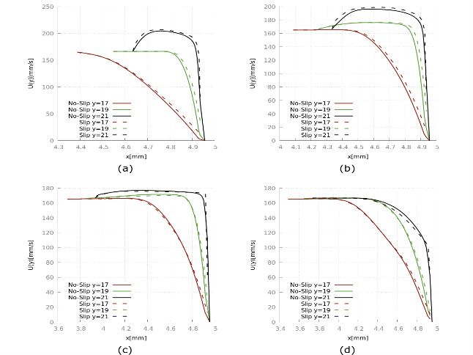
Figure 3. Comparison of the velocity profiles for no-slip and slip models at various cross-sections as highlighted in Fig 2. a) SWG=300 µm, b) SWG=600 µm, c) SWG=1000 µm and d) SWG=1200 µm.

Figure 2 depicts representative streamlines overlayed on a pressure distribution for SWG=600µm no-slip case. Figure 3 compares the development of velocity profiles along the converging gap for all the cases. Initially, the flow is driven by the shear from the moving substrate and as the flow develops, the linear shear-flow profile evolves to a truncated parabola, for the smaller slot-web gaps. In addition, velocities higher than the moving substrate are observed in the bulk of the flow. As the SWG is increased, the pressure drops generated are reduced, and the flow changes to predominantly shear-driven throughout the converging gap. As we compare the no-slip (represented by solid lines) and slip (dashed lines) cases, for the pressure-driven cases (viz. SWG=300 µm and SWG=600 µm), slip is observed to be beneficial as the lower wall-shear stresses along the slip-wall lead to marginally higher velocities at the slot exit. Also, the pressure drops are slightly reduced along the converging region, compared to a no-slip case. For example, pressure drops of around ~8% for SWG=300 and ~6.5% for SWG=600 case were observed, compared to the corresponding no-slip cases. However, as the flow becomes more shear-driven, these benefits are not perceived as the shear-rates formed are too low to generate a considerable slip velocity that could influence the region beyond a few microns from the wall.

Conclusions and outlook
In this study, a nonlinear-slip velocity model was developed and used to examine the slot-coating process for a nanocellulosic material. For the studied parameters, the introduction of slip not only marginally affects the force balance across the slot-die, but also the pressure drops across it. Consequently, the velocity profile is slightly shifted upwards with considerable slip-velocity generated at the wall, for predominantly pressure-driven flows, while the effect of the slip was not perceived when the flow mainly is driven by shear.

Acknowledgements
KSLA Tandem Forest Values supported this work via grant TFV I 2018 for the project -‘SimNano – Numerical simulation of coating processes for nanocellulosic materials'.

References
[1] Ma, H. and Graham, M.D., 2005. Theory of shear-induced migration in dilute polymer solutions near solid boundaries. Physics of Fluids, 17(8), p.083103.
[2] Mondy, L.A., Brenner, H., Altobelli, S.A., Abbott, J.R. and Graham, A.L., 1994. Shear‐induced particle migration in suspensions of rods. Journal of Rheology, 38(2), pp.444-452.
[3]Koppolu, R., Abitbol, T., Kumar, V., Jaiswal, AK, Swerin, A. and Toivakka, M., 2018. Continuous roll-to-roll coating of cellulose nanocrystals onto paperboard. Cellulose, 25(10), pp.6055-6069.
[4] Hirt, C.W. and Nichols, B.D., 1981. Volume of Fluid (VOF) method for the dynamics of free boundaries. Journal of computational physics, 39(1), pp.201-225.
[5] Kumar, V., Nazari, B., Bousfield, D. and Toivakka, M., 2016. Rheology of microfibrillated cellulose suspensions in pressure-driven flow. Applied Rheology, 26(4), pp.24-34.

