An Experimental Investigation of Multilayer Flow in a Slide Die Coating Process

Janghoon Park¹, Jason Pfeilsticker¹, Kristianto Tjiptowidjojo², P. Randall Schunk^{2,3}, Scott A. Mauger¹, Michael Ulsh¹

¹ Chemistry and Nanoscience Center, National Renewable Energy Laboratory, 15013 Denver West Parkway, Golden, CO 80401, USA

² Department of Chemical and Biological Engineering
University of New Mexico, Albuquerque, NM 87131, USA

³ Advanced Materials Laboratory, Sandia National Laboratories, Albuquerque, NM 87185, USA

Presented at the 20th International Coating Science and Technology Symposium
September 20-23, 2020
Minneapolis, MN, USA

ISCST shall not be responsible for statements or opinions contained in papers or printed in its publications.

Extended Abstract (ten page maximum):
Roll-to-roll (R2R) coating technology has been actively applied not only for conventional film production but also for emerging energy devices such as organic solar cells, organic light emitting diodes, batteries, smart windows, and fuel cells. The devices are multilayer structures requiring several coating and drying steps when implemented in a serial fashion, which increases capital costs and energy consumption. Simultaneous multilayer (ML) coating technologies present an opportunity for cost reductions and improved process efficiency by reducing equipment footprint and the number of process steps [1].

In this study, we experimentally investigate ML slide coating flow for the manufacturing of fuel cell membrane electrode assemblies (MEAs) [Fig. 1]. The MEA is the main component of fuel cell stacks, which consists of three layers: anode catalyst layer, cathode catalyst layer, and polymer electrolyte membrane. For ML slide coating, understanding fluid properties such as density, surface tension, and viscosity are necessary for stable flows and limiting intermixing of the miscible layers.
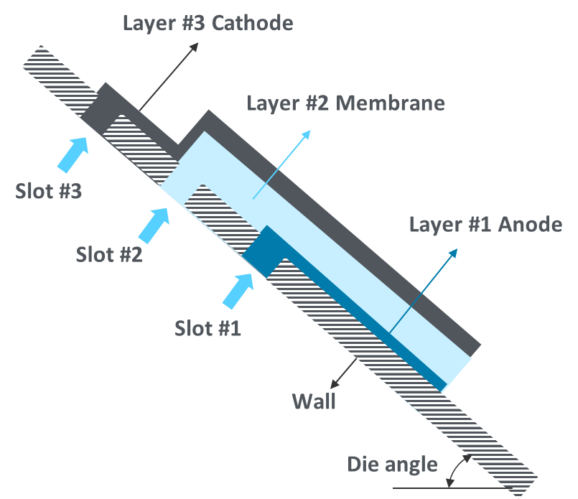
Fig. 1. Concept diagram of ML slide coating of MEAs.

Here, we utilize a design-of-experiment methodology – Box-Behnken design (BBD) [2] – to correlate ink formulation parameters to fluid properties. In the BBD, Pt/carbon catalyst concentration, 1-propanol% in a water/1-propanol mixture and ionomer to carbon (I/C) mass ratio were the main variables. The Nafion ionomer dispersions were used for the ink formulation. The measured shear-viscosities of the Pt/carbon inks formulated through the BBD are shown in Fig. 2.
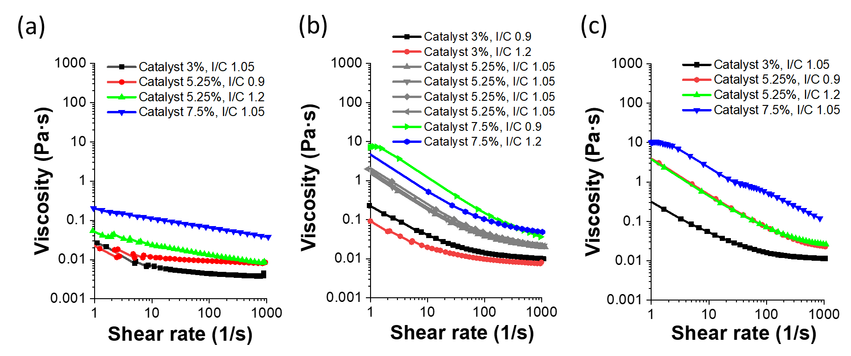
Fig. 2. Steady-shear viscosities of Pt/carbon inks which are formulated based on BBD: sorted by 1-propanol% (a) 10%, (b) 25%, and (c) 50%.

By performing analysis of variance (ANOVA), the effect of viscosity (Y) on the combination of catalyst% (X₁), 1-propanol% (X₂) and I/C ratio (X₃) can be precisely analyzed. The ANOVA results based on the viscosity value (Y) at 1/s shear rate are presented as Table 1, which lists the degree of freedom (DF), sum of squares (SS), mean square (MS), F value, and probability (P) value. The R-square value of this analysis was 0.983, which showed excellent statistical reliability. For the viscosity response (Y), the three main variables (X₁, X₂, and X₃) showed all statistically significant values with P values less than 0.05. From the main effect point of view, catalyst% (X₁) has the largest effect on the viscosity with the largest F value in the regression analysis. The 1-propanol% (X₂) also has a significant main effect, but I/C ratio (X₃) has a very minor effect on the viscosity values. Based on the regression analysis, it is possible to derive optimal mixing conditions to obtain desired ink characteristics for each layer.
Table 1. ANOVA result for ink viscosity at 1/s shear rate (Y)
 | DF | SS | MS | F value | P value
X₁ | 1 | 59.83797 | 59.83797 | 900.0383 | 8.13×10-5
X₂ | 1 | 41.13245 | 41.13245 | 618.6837 | 1.42×10-4
X₃ | 1 | 0.89292 | 0.89292 | 13.43057 | 0.03513
X₁² | 1 | 4.3467 | 4.3467 | 65.37988 | 0.00395
X₂² | 1 | 0.01572 | 0.01572 | 0.23643 | 0.6601
X₃² | 1 | 0.19658 | 0.19658 | 2.95683 | 0.18401
X₁X₂ | 1 | 24.78297 | 24.78297 | 372.767 | 3.03×10-4
X₁X₃ | 1 | 1.23921 | 1.23921 | 18.63934 | 0.02289
X₂X₃ | 1 | 0.009 | 0.009 | 0.13532 | 0.7374
Error | 6 | 2.22075 | 0.37012
Lack of fit | 3 | 2.0213 | 0.67377 | 10.13429 | 0.04444
Pure Error | 3 | 0.19945 | 0.06648
Total | 21 | 136.895

Using the ink properties obtained from the BBD, we performed numerical flow simulations to obtain proper process conditions to guide experimental coating trials. Finally, experimental verification is performed on a ML slide die and the degree of miscibility was observed for various ink formulation conditions. This research is expected to serve as a practical guide for determining the optimal ink formulation and operating conditions when using ML slide coating for fuel cell manufacturing.

References
[1] Buerkin, Cornelia K., et al. "Investigation of interfacial instabilities with a two-layer slide coating process." Journal of Coatings Technology and Research 14.5 (2017): 991-1001.
[2] Shakeel, Faiyaz, et al. "Box–Behnken statistical design for removal of methylene blue from aqueous solution using sodium dodecyl sulfate self-microemulsifying systems." Industrial & Engineering Chemistry Research 53.3 (2014): 1179-1188.

Acknowledgements
This work was authored by the National Renewable Energy Laboratory, operated by the Alliance for Sustainable Energy, LLC, for the U.S. Department of Energy (DOE) under Contract No. DE-AC36-08GO28308. Funding provided by the U.S. Department of Energy, Office of Energy Efficiency and Renewable Energy, Advanced Manufacturing Office. The views expressed in the article do not necessarily represent the views of the DOE or the U.S. Government.
Sandia National Laboratories is a multimission laboratory managed and operated by National Technology and Engineering Solutions of Sandia, LLC, a wholly owned subsidiary of Honeywell International Inc., for the U.S. Department of Energy’s National Nuclear Security Administration under contract DE-NA0003525.

